

**___________________________________________________________________________**

Identifying & Categorizing Offensive Language in Social Media

(A Machine Learning Approach)

**___________________________________________________________________________**

Yagyansh Bagri ’21

“Submitted for the Degree of B.Sc. in Data Analytics”

Faculty of Computer & Information Sciences  
March 29, 2021

**Registration Number** – 201642765

**Marking Scheme** – Software Development Based

DISCLAIMER

The following exploratory project will have examples of profanity across a certain number of chapters.

The following report consists of screenshots, words or language consisting of profane, vulgar or offensive texts.

The following report consists of statements containing visual or written representations of people or events that some cultures may protect.

The following report may contain triggers for people with post-traumatic stress disorder.

The following report, in no manner, intends on promoting profanity and abuse. The sole purpose and goal are to provide an in-depth understanding to the reader and the widespread problem that requires addressing.

DECLARATION OF AUTHORSHIP

I, Yagyansh Bagri, declare that this thesis titled **“Identification & Categorizing Offensive Language in Social Media (A Machine Learning approach)”** and the work presented in it consist of my thoughts and findings and extensive research carried out.

The research presented within the thesis has been carried out while in candidature for a Bachelor’s degree in **Data Analytics** at **The University of Strathclyde, Glasgow**.

In instances, when I have consulted published works of others, it has been explicitly attributed.

In instances when I have quoted from works of others, the sources have been mentioned. Except for quotations, the entirety of this project report is of my own.

I have acknowledged all the primary sources of aid and information gathered and understand that my project documentation will be stored within the library of **The University of Strathclyde, Glasgow.**

“Except where explicitly stated all the work in this report, including appendices, is my own and was carried out during my final year. It has not been submitted for assessment in any other context.”

Signed: **Y.Bagri**

Dated: **29th March 2021**

ABBREVIATIONS

**AI**  **A**rtificial **I**ntelligence

**DL**  **D**eep **L**earning

**ML M**achine **L**earning

**LR L**ogistic **R**egression

**NLP N**atural **L**anguage **P**rocessing

**SVM S**upport **V**ector **M**achines

**BERT B**idirectional **E**ncoder **R**epresentations from **T**ransformer

**LSTM L**ong **S**hort-**Term M**emory **N**etworks

**OLID O**ffensive **L**anguage **I**dentification **D**ataset

**CNN C**onvolution **N**eural **N**etworks

**RNN R**andom **N**eural **N**etworks

# ABSTRACT

Sixty-five billion **WhatsApp**Messages, five hundred million **Tweets** and three hundred and fifty million posts on **Facebook** are exchanged, tweeted and uploaded on a day-to-day basis. However, **forty-eight** per cent of people say that they experience depression and feel lonelier in general because of derogatory content targeted towards them.

The **COVID-19** Pandemic has altered just about everything, including our relationship with the internet and how we use it. Today we are more online than ever, with a recent study at [Stanford University](https://www.gsb.stanford.edu/faculty-research/working-papers/social-media-news-consumption) highlighting an increase of **seventy-two** per cent in social media consumption. This increase in social media consumption is essentially because of the **Lockdown Regulations** and **Stay-At-Home** orders, leaving individuals with no other option but to execute tasks and engage in conversations virtually.

As the number of tweets, posts and messages increases, so does the unacceptable behaviours of its active social media users. One such unappealing action is offensive language and abusive content, which could lead to disastrous consequences. Previous studies and surveys effectively point out how hateful language within social media is a serious concern that affects many individuals. Therefore, it is necessary to efficiently identify and categorize offensive language by analysing tweets, posts and comments in real-time if possible.

A considerable number of techniques have been executed to identify offensive content, but they are incredibly time-consuming. This thesis aims at unifying the variety of approaches implemented in detecting foul language. The primary inspiration lies in how our model would automate and accelerate the identification and categorization of offensive content. This project presents profound learning approaches applied to the class of categorizing harmfulness within online remarks. We study and build upon some of the best baseline methods like but not limited to **CNN**and **Logistic Regression**, in detecting offensive language.

For this project, we utilize the freely accessible **OLID 2019 Dataset** from OffensEval Competition and aim to outflank the past work by trying to better the **Macro F1-Score**on this **OLID 2019 Dataset**. Lastly, we hope for a continuous framework that could be implemented on different social media platforms to identify and categorize offensive language, with adequate measures to standardize the conduct on these sites for the general public.

# ACKNOWLEDGEMENTS

I am incredibly grateful to my supervisors **Dr. Leif** & **Dr. Amal**, for their unconditional support and guidance in navigating me throughout my Machine Learning project. Their daily messages on **Slack** and follow up calls over **ZOOM** has been a source of encouragement and motivation in such uncertain times that all of us face. I am fortunate to work under **Dr. Leif’s** expertise within the field of Natural Language Processing and applaud his approach in solving every query that I have stumbled upon.

**Dr. John Levine** single-handedly fostered an interest in Artificial Intelligence and Machine Learning during my freshman year at **The University of Strathclyde.** It gauged my curiosity within Machine Learning and enabled me to choose a project in this area of knowledge.

Additionally, I would like to thank my second marker, **Dr. Kieren**, for his invaluable feedback over my Project Progress Presentation. **Dr.Kieren’s** remarks gave a different outlook towards the project and propelled me to work towards the lesser developed parts of my research.

Lastly, I would like to thank the entire **Department of Computer and Information Sciences** for providing an extensive amount of support virtually.

*I Dedicate this thesis to my loving mother, Mrs. Abhidha Bagri, and my supportive father, Mr. Raj Kumar Bagri, for providing the constant support and encouragement needed throughout my bachelor’s degree….*

TABLE OF CONTENTS

ABSTRACT 5

ACKNOWLEDGEMENTS 6

1. Introduction 9

1.1 Motivation 9

1.2 Problem Definition: Hate Speech 10

1.3 Need for Automatic Detection 12

1.4 Countermeasures Deployed Against Hate Speech 13

1.5 High Level Approach to Problem 14

1.6 Aims & Objectives 16

1.7 Project Specifications 17

1.8 Report Structure 18

2. Background & Related Work 20

2.1 Machine Learning 20

2.2 Problem Description 21

2.3 OLID 2019 Dataset 23

2.4 Data Pipeline 23

2.6 Evaluation Metrics 24

2.6.1 Precision 24

2.6.2 Recall 25

2.6.3 Macro F1-Score 25

2.6.4 Accuracy 25

2.7 Previous Approaches & Strategies Implemented from Literature 26

2.7.1 Logistic Regression 26

2.7.2 Support Vector Machines 27

2.7.4 Long Short-Term Memory (LSTM) 29

2.7.5 Convolutional Neural Networks (CNN) 30

2.7.6 Bidirectional Encoder Representations from Transformer (BERT) 32

2.8 Baseline Approaches to Problem 32

3. Proposed Methodology 33

3.1 Innovative Strategy Aimed 33

3.2 Adopted Dataset 35

3.3 Pre-Processing of Dataset 36

3.4 Splitting of Dataset 41

3.5 Distinctive Methods Implemented 42

3.6 Additional Baseline Performed 43

3.7 Parameters Employed on Recommended Approaches 45

3.8 Supplementary Evaluation Conducted 46

4. Software Design & Testing 48

4.1 Software Methodology Performed 48

4.2 Key Libraries & Features Implemented 49

4.3 System Testing Conducted 51

5. Results & Outcomes 54

5.1 Convolutional Neural Network Model Results 54

5.2 Logistic Regression Model Results 54

5.3 Comparison of Results with OffensEval 2019 55

6. Conclusion & Future Development 56

References 57

Appendices 58

1. Introduction

When the entire world is plagued with the novel **COVID-19 Pandemic,**Social Media has proven to be an invaluable tool for staying in touch with our friends and loved ones. Social Media is one of the most influential and engaging innovations of the 21st Century; it has provided greater accessibility to the rest of the world. However, Social Media is a double-edged sword. [(Social Dilemma, Netflix)](https://www.cinemablend.com/news/2555346/what-is-the-social-dilemma-things-to-know-about-the-netflix-documentary-before-you-watch)

 In today’s age, all of us are vulnerable to social approval. We care about how people perceive us on posting tweets on **Twitter**, capturing check-ins on **Facebook** and uploading posts on **Instagram**. From getting rewarded with likes (👌🏻), hearts (❤️) and thumbs-up (👍), Social Media today has become the perfect platform for instant gratification. This quick form of satisfaction has simultaneously resulted in an increasing amount of anti-social behaviour observed within various social media platforms. These forms of unacceptable behaviour include **abusing**, **cyber-bullying**, **hate speech** and **trolling**. Additionally, this form of offensive behaviour is not limited to children and young adults; anyone with or without social media access could be a victim of it. [(Young Minds, UK)](https://youngminds.org.uk/find-help/looking-after-yourself/social-media-and-mental-health/)

## Motivation

Meaningful changes across the world have occurred because of Social Media platforms. Ranging from the recent **Black Lives Matter**protest in 2020 to the **Hong Kong Anti Extradition Law Protests**in 2019, platforms like **Facebook**and **Twitter**have given the world an extraordinary stage to express their opinions and sentiments in response to a particular individual, gathering or an event. This advanced form of media has become an exceptional resource to exchange information and provides individuals the complete liberty to speak freely with any one part of the platform.

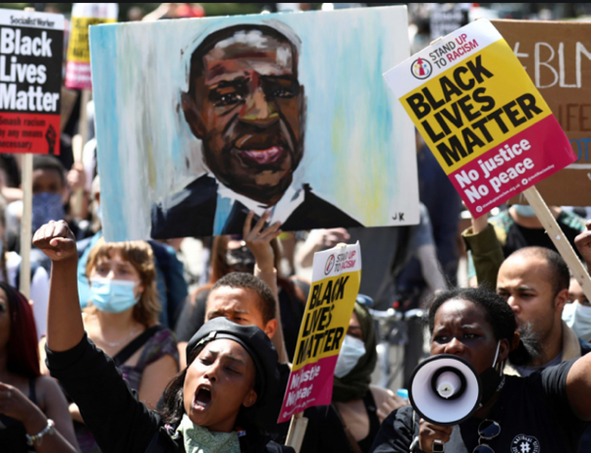 

[Figure 1.1: Screenshot of the BlackLivesMatter and Extradition Law Protests](https://www.pri.org/stories/2020-06-16/black-lives-matter-organizers-us-and-uk-compare-and-contrast-global-movement)

This rapid acceptance these platforms have received has also resulted in an alarming surge of notoriety within them. A significant challenge these organisations face is the detection of **Offensiveness** and **Profanity** within their platforms. Examples of profanity can include obscene gestures, humiliating pictures or demeaning comments posted on social networks. Once these pictures, comments and videos are uploaded or tweeted, it is challenging to take them off from social media sites. These instances can occur twenty-four hours a day and seven days a week, reaching their victim when alone, outside or even in a sports field [(Robinson & Jeanne Segal. 2020)](https://www.helpguide.org/articles/abuse/bullying-and-cyberbullying.htm).

A recent incident that catapulted platforms like **Twitter, Instagram, Facebook & Snapchat**to strengthen their approach against **Offensive & Hate Speech**was the United States Capitol stormingin January 2021. The infamous episode that would remain a black mark in United States history was propagated by **Donald Trump, Former President of the United States**. It was essentially carried out by a series of offensive tweets by Mr. Trump against political members, resulting in propagating profanity and inciting violence amongst the greater American public. It not only caused the death of over five civilians and a nation-wide curfew but also led to the permanent ban of Mr. Trump across all social media platforms.

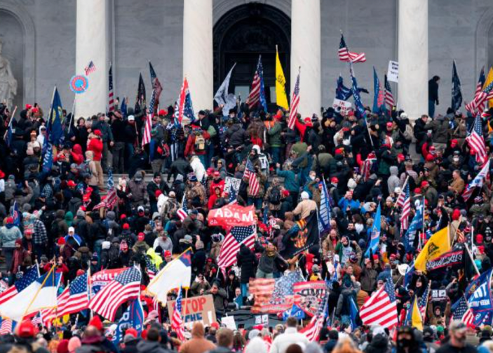 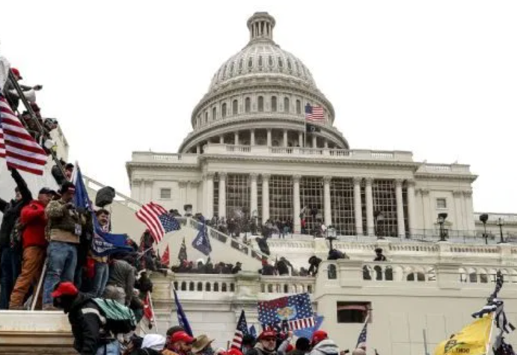

[Figure 1.2: Screenshot of the Storming of the US Capitol on the 6th of January 2021](https://www.vox.com/2021/1/6/22217445/protesters-storm-us-capitol-trump-congress)

Posting hate speech or cultivating profanity against an individual, organisation, or event should not be acceptable since it can lead to catastrophic consequences. It is therefore extremely critical to prevent such actions of misconduct and misdemeanour.

## Problem Definition: Hate Speech

All over the world, we are witnessing a rise in xenophobia, racism and intolerance - including anti-Muslim hatred and persecution of Chinese nationals [(Guterres, United Nations Secretary General)](https://www.hrw.org/news/2020/05/12/covid-19-fueling-anti-asian-racism-and-xenophobia-worldwide). Social media has become an effective form of communication to promote bigotry particularly during the **COVID-19 Pandemic**. Public dissent is being weaponized for political gain that stigmatizes and dehumanizes refugees, migrants, women and the so-called "other".

The United Nations defines the term **"Hate Speech"**as any kind of communication in speech, writing or behaviour, that attacks or uses pejorative or discriminatory language regarding a person or a group based on who they are, in other words, based on their religion, ethnicity, nationality, race, colour, descent, gender or another identity factor. [(United Nations, 2018)](https://www.un.org/en/genocideprevention/documents/UN%20Strategy%20and%20Plan%20of%20Action%20on%20Hate%20Speech%2018%20June%20SYNOPSIS.pdf)

By limiting Hateful content, we do not intend to prohibit or prevent freedom of speech for every individual. It essentially implies to keep hate speech from escalating into something more dangerous, particularly **incitement**to **discrimination**, **hostility**and **violence.**[(Allan, Facebook)](https://about.fb.com/news/2017/06/hard-questions-hate-speech/)

Today we have created a world where an online connection has become primary, especially for younger generations. It has led many societal members and students, in particular, to engage with social media platforms in a manner not known before. Subsequently, a higher engagement rate has led the users to believe it is “socially acceptable” to promote and post about profanity since there are no disciplinary measures in place. Alternatively, if there are appropriate measures for such actions, individuals would think twice before carrying out derogatory acts.

In its biannual [**Community Standard Enforcement Report**](https://www.forbes.com/sites/niallmccarthy/2020/05/13/facebook-removes-record-number-of-hate-speech-posts-infographic/?sh=12e767973035)published in March 2020, **Facebook** stated the company took actions against **9.6 Million**posts that contained offensive language and promoted profanity. Technological improvements mainly achieved this record number for automatically identifying offensive images and text. However, the organisation realised a large portion of posts remains undetected. Social Media sites like Twitter and Facebook have learned that these hidden posts cannot be detected by relying on victims or users reporting abusive incidents. Manually identifying abusive and hateful content by moderators would be almost impossible because of the sheer number of posts generated on social media platforms.  

Today there are over **100**Social Media Platforms; however, **Facebook**and **Twitter**record the highest number of posts, comments and tweets containing offensive text or promoting abusive behaviour. Fundamentally, this presents an interesting problem of whether combining the data from both the platforms would strengthen the **Machine Learning**model or not.

However, since **Facebook**and **Twitter**have different parameters in how their forum operates and posts are uploaded, it would be difficult and cumbersome to focus our efforts on two broadly distinguished areas.

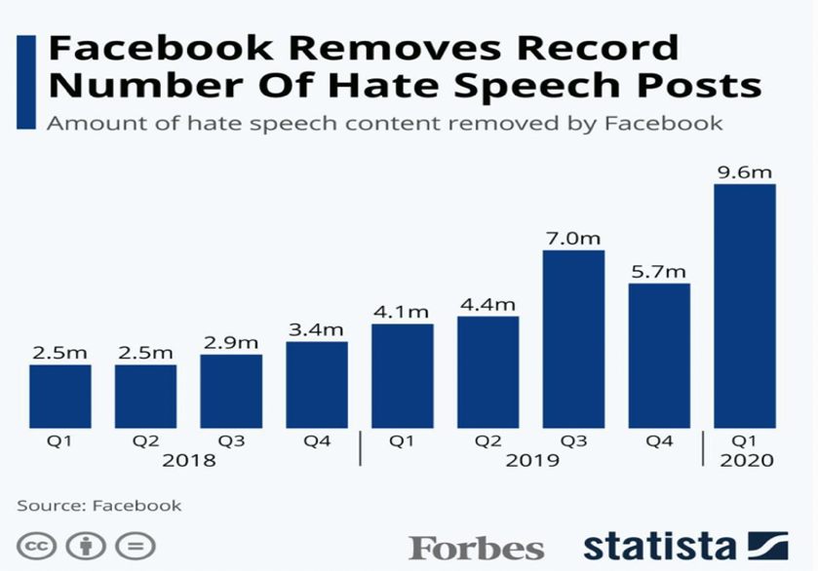

[Figure 1.3: Screenshot of the Record Number of Hate Speech Posts Removed by Facebook](https://www.forbes.com/sites/niallmccarthy/2020/05/13/facebook-removes-record-number-of-hate-speech-posts-infographic/?sh=12e767973035)

 The distinct difference lies in the fact that **Twitter**allows users **280**characters to tweet in comparison to **Facebook’s 63206** characters for a post. After extensive research from previous studies, we have decided to build a **Machine Learning**model that can perform well on a dataset with a reduced character level and subsequently implore techniques to optimise the model. Therefore, this project focuses on identifying and categorising offensive language present within the publicly available Twitter dataset from the [**OffensEval 2019 Competition**](https://sites.google.com/site/offensevalsharedtask/offenseval2019).

Furthermore, we aim to address the need for an automatic detector of offensive language on social media through this project. By enhancing global resilience against this insidious phenomenon, we can strengthen the bond of society and build a better world.

## Need for Automatic Detection

The fundamental problem of our generation is that “**It is Imperative to be Popular**”.

People must look like they have a better life than they do. Everyone must agree with what we have to offer; if not, then be subjected to hateful speech and resentment. This self-obsessed behaviour has made us addicted to our echo chambers, with a constant need for people to validate our thoughts.

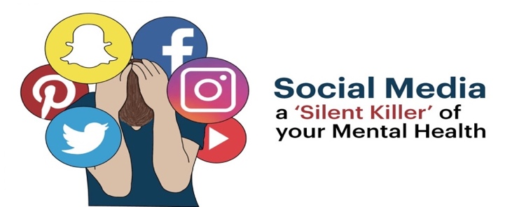

[Figure 1.4: Screenshot from a study carried out at Harvard University](https://www.hsph.harvard.edu/news/features/social-media-positive-mental-health/)

Social Media has essentially changed how we interact with the world and engage with individuals. Scientific research carried out at **Harvard University**by researcher [**Trevor Haynes**](https://sitn.hms.harvard.edu/flash/2018/dopamine-smartphones-battle-time/)focuses on how engagement with social media releases Dopamine. The same chemical makes us feel good when we associate a particular activity with pleasure or expect a reward; in the case of Twitter, it would be the number of **retweets, comments, likes**and **follow backs.** Today an entire generation has access to an addictive numbing chemical called **Dopamine**through social media as they are going through the high stress of their jobs, university or even the ongoing pandemic. This generation doesn’t have the coping mechanism to deal with this stress; so, when a significant amount of anxiety starts to show up in their lives, they’re not turning to a person; they’re turning to **Social Media.**They are turning to these sites that offer temporary relief.

People who spend more time on social media platforms face more forms of depression, abuse, harassment and anxiety than people who spend less time on these sites. For instance, when we upload a tweet on Twitter or a post on Facebook, there’s a moment in our mind we are vulnerable to know what other people think.  We evolved to care about whether other people in our tribe; think well of us or not because it mattered. But were we developed to think about what **10,000 people think of us**?

These concerns are not baseless, and social media companies face immense pressure to better monitor and police their platforms for hate speech, bullying and offensive content. This has led to the growing need for an automatic detecting mechanism to identify, categorize and eliminate hateful content.

## Countermeasures Deployed Against Hate Speech

With the growing amount of pressure from various forums and tribunals, it has become imperative for social media websites to regulate how their users interact with one another. Social Media platforms like **Twitter**have always been advocates of encouraging their users to express themselves; **Twitter**does condemn acts of hate speech, abuse, cyberbullying and harassment.

Since 2019, **Twitter**has prioritised gathering feedback from its users, external experts, and their teams to develop their **Hateful Conduct Policy.**The **COVID-19 Pandemic**accelerated the Hateful Conduct Policy formulation due to the exponential consumption of social media and rise in hateful speech across a diverse range of tweets.

The updated rules and regulations by **Twitter**need to be strictly followed by every user. If not adhered to can result in temporary or permanent suspension from the social media platform **Twitter.**A certain number of rules include but not limited to are as follows:

1. Wishing, hoping or calling for serious harm on a person or group of people is strictly banned.
2. References to mass murder, violent events, or specific means of violence where protected groups have been the primary targets or victims is strictly forbidden.
3. Instigation against protected categories is strictly prohibited. [(Twitter; Hateful Conduct Policy)](https://help.twitter.com/en/rules-and-policies/hateful-conduct-policy)

## High Level Approach to Problem

Twitter and Facebook have become the most likely origins of cyberbullying. However, with Twitter being a micro-blogging social media platform that allows users to read or post messages limited to **280 characters,**our study focuses on detecting offensive language in a publicly available Twitter dataset.   
We chose the **Twitter** dataset due to its **280-character** limit compared to **Facebook’s** exponential **63,206-character** limit. It was bearing in mind the long-term goal of allowing the automated offensive language detection model to tackle smaller puzzles before being exposed to astronomically complicated queries.

All the listed users on Twitter can read or post messages. These posts are called "Tweets." Twitter makes these tweets public by default; this essentially means that users not part of the social media platform can read the publicly available tweets. Promoting profanity and hate speech can surface in diverse forms, such as posting humiliating and disturbing pictures or videos.

There are over **500 million** **tweets**generated per day and **70 per cent**of the tweets consist of language deemed to be derogatory and unfavourable, with the most common insults including words like - **"f*CK", "n*gg*", "b*tch".**This rise of anti-social behaviour has essentially sparked a significant

debate if **Twitter** is an epicentre for the **Promotion of Offensive Language.**

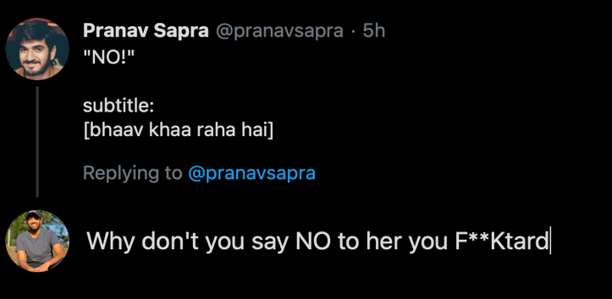  
[Figure 1.5: Screenshot of a Prime Example highlighting Offensive Content](https://twitter.com/pranavsapra?ref_src=twsrc%5Egoogle%7Ctwcamp%5Eserp%7Ctwgr%5Eauthor)

The tenacity to implement a Machine Learning technique to identify and categorise insulting and hurtful content on **Twitter**or the different social media platforms could not have been any higher. The primary **stakeholders** for the success of this project would not only be the **OffensEval 2019 Competition Organisers**and **Dr. Leif**& **Dr. Amal -**(the project supervisors) but mainly the "**Users". Users** who consume social media and are greatly affected by the widespread hatred leading to depression, anxiety, and suicide.  With an automated moderator, we would be able to flag offensive content and categorise it accordingly. Additionally, users could receive warnings before posting hateful speech or could filter unwanted content. We are subsequently hoping to provide a much less impudent feed and enriching the lives of the people interacting with the platform, in this case being **Twitter**.

There are over **6,500**spoken languages globally, but the **Social Media**dialect has kept evolving. The way users communicate over **Social Media**can be too complicated for a machine to understand with no background knowledge. Sentences could contain double meaning words **(come on me)**, grammatical errors **(f*cter)**and misinterpreted emojis **(**🍆**).**Overall a single word can have multiple meanings and multiple interpretations for a user over **Social Media.**Meanings depend on the context they are in for humans and are much simpler to define than machines. Novel improvements within **Machine Learning** and **Natural Language Processing**have made the once implausible task of understanding semantic and contextual inference more achievable. Initially, the strategy to filter hateful content using **List Based Approaches**had been proposed, but they failed to capture the context in which the word is used in a sentence.

**For example, the sentences:**

**"I hate Mexican food"** and **"I hate Mexican people."**

The above two sentences have the key flagged word being **"Hate",**but both sentences have an entirely different meaning. As human beings, we are aware that **Profanity**could be used positively but what about **Machines?**

For the above sentences if we implement a **List Based Filtering Approach**, the machine learning model would flag off both the above sentences as **Offensive.** To solve such problems, present in front of us, the previous Machine Learning techniques introduced are the state-of-art model **Bidirectional Encoder from Transformations (BERT)**performed by **Google** and a **Convolutional Neural Network (CNN).**

BERT:

The **BERT**model enables **Google**and many other social media platforms to discern the context of words in search queries. Using the above two sentences as examples, the word **"hate"**has two different meanings, which would be obvious to humans but less so to a social media platform. **BERT**is designed to distinguish between such nuances to facilitate better results and classify offensive content. [(Pandu Nayak, Google Vice President of Search)](https://blog.google/products/search/search-language-understanding-bert/)

CNN:

The **CNN (Convolutional Neural Network)**model is a **Deep Learning**algorithm that takes an input image, assigns importance (learning weights and biases) to various aspects/objects in the image and enables the model to differentiate one image from another. [(Yoon Kim)](https://www.aclweb.org/anthology/D14-1181.pdf)

Through the lifespan of our exploratory venture, we propose to unify the different machine learning techniques implemented to better the **Macro F1-Score**for detecting offensive content on social media. We hope to better the evaluation metrics by fine-tuning the models and experimenting with different parameters not introduced before. We also recognise the possibility of obtaining a lesser  **Macro F1-Score**. However, this project’s very purpose is to help discover and attempt new approaches that were not ventured into before.

As Thomas Alva Edison says, and I quote,*"I never failed once at making a light bulb but found 99 ways of how not to make one."* [*(Edison)*](https://quotefancy.com/quote/916676/Thomas-A-Edison-I-never-once-failed-at-making-a-light-bulb-I-just-found-out-99-ways-not)

## Aims & Objectives

This machine learning project endeavours to use the **OLID 2019 Dataset**from **SemEval 2019 Competition.**We aim to execute **Task 6,**which is **Identifying & Categorising Offensive Language in Social Media.**The **OLID 2019 Dataset**consists of a large corpus of Tweets, and we intend on using Machine Learning techniques to detect and classify offensive tweets accordingly. By the end of our exploratory venture, we aim to have developed a more reliable automated moderator than the one's present.

The main goals of our thesis are listed below:

1. Investigate and Define the **OLID 2019 Dataset**.
2. Critique previous **ML** methods that have been previously introduced in the past and identify the best baseline approach.
3. Execute and evaluate two baseline methods from **SemEval OLID** track.
4. Recommend and Implement a new procedure to solve the problem, i.e. a new **ML**method by adding in new parameters or unifying different techniques together.
5. Conduct and Examine the proposed **ML**method and if time permits fine tune it using the **GPU** freely accessible via **GoogleColab.**
6. Examine the different parameters associated with the method and interpret how it affects the **ML**model's performance.
7. Analyse and Evaluate the different approaches using our evaluation metrics to compare distinct models.

Based on the objectives of our project, the research question that presents itself in front of us is:

*How can we use Machine Learning to detect and categorise offensive content on social media?*

## Project Specifications

For our exploratory venture, the fundamental requirements and specifications are as follows:

**OLID 2019 Dataset:**

The Offensive Language Identification Dataset **(OLID)** from the **SemEval Competition**comprises **14,100** annotated English Tweets. Of the **14,100** tweets, **13,240** tweets have been provided as **Training Data** and **860** tweets have been provided as **Testing Data.**

**Technology & Libraries:**

We will be using **Python**to execute the bulk structure of our coding requirements. Within **Python,**we would be making use of the following libraries available:

1. **Scikit-Learn**
2. **NumPy**
3. **Pandas**
4. **TensorFlow**
5. **Keras**
6. **Regex**

Additionally, we would also be using **Google Collab**to fine-tune our models because of the exponential amount of **Graphics Processing Unit (GPU)**provided at no cost. A detailed description of our technological libraries implemented is provided in **Chapter 4.2: Key Libraries & Features Implemented.**

**Evaluation Metrics:**

To estimate the method that can potentially improve in filtering offensive content, we would be using the following parameters:

1. **Macro F-1 Score**
2. **Accuracy**
3. **Precision**
4. **Recall**

**A much more in-depth description of our evaluation metrics is provided in Chapter 2.6: Evaluation Metrics.**

## Report Structure

The structure of our report is organized into a set of six chapters.

The **first chapter** provides the motivation and understanding of the problem, alongside addressing the need to solve the problem and the countermeasures deployed by social media websites, in this case, **Twitter**, to combat hate speech. We also provide a high-level overview of our approach and strategy in detecting offensive language.

The **second chapter**provides an account of the various methods and techniques implemented in the past and a brief criticism of them. Side by side, we also offer an in-depth description of the problem posed in front of us and the dataset at hand. The proposed evaluation metrics and review the preceding methodologies performed. Additionally, it provides a high-level overview of our data pipeline and presented baseline techniques for our exploratory venture.

The **third chapter**comprises an in-depth account and defence of our aimed approach. Additionally, it depicts a detailed report of the operations mentioned within the **Data Pipeline**in the **OLID Dataset**and the reasoning behind our recommended **Proposed Approach.**

The **fourth chapter**consists of our software design and technique we have executed. Parallelly, we also provide a comprehensive record of the critical packages, classes and libraries we have used.

The **fifth chapter**includes the results of our **Baseline Implementations**along with how they change with varying parameters. Additionally, comparing our outcomes with results from previously participated teams in the **SemEval 2019**competition has also been reported.

The **sixth**and **final chapter**of our exploratory venture provides our conclusion and scope of future work that could be implemented in hate speech identification.

2. Background & Related Work

Through the second chapter of our report, we will explain why we are implementing machine learning techniques to address the problem of Identifying and Categorising Offensive Language on Social Media. Parallelly, we will also define the **OLID 2019 Dataset** and critique the previous methods performed in this area of research.

## 2.1 Machine Learning

We know that humans learn from past experiences and machines follow instructions given by humans. But **What If Humans Can Train the Machines** to learn from **Past Data**and execute tasks **Faster**than **Human Beings?**

[(Towards Data Science)](https://towardsdatascience.com/a-gentle-introduction-to-machine-learning-599210ec34ad)

Today there is an overflow of data in the world generated by computers, phones, and other devices; this will only continue to grow. Traditionally, human beings have analysed data and adapted systems to the changes in data patterns. However, as the volume of data surpasses the ability of humans to make sense of it and manually write rules, we will turn increasingly to automated systems that can learn from the data and, more importantly, the changes in data to adapt to a shifting landscape. **Machine Learning**brings the promise of deriving meaning from all the data at our disposal to accurately identify and categorise hate speech in a much swifter manner.

“Any sufficiently advanced technology is indistinguishable from magic.”

- [Arthur C. Clarke](http://lab.cccb.org/en/arthur-c-clarke-any-sufficiently-advanced-technology-is-indistinguishable-from-magic/#:~:text=In%201962%2C%20in%20his%20book,technology%20is%20indistinguishable%20from%20magic%E2%80%9D.)

**ML**is not essentially magic but tools and technology that one can utilize to find meaning in our data. For the simplicity of our exploratory venture and the reading audience, **Machine Learning**is the process of **Using** **Data** to **Answering** **Questions**.

**Using data**is what we refer to as feeding our **ML** model with **Training Data,**while **Answering Questions**is referred to as making **Predictions based on the Testing Data provided.**

[(GoogleCloud)](https://www.voicetube.com/v3/videos/59623)

**Training refers to using the data available to inform the creation and fine-tuning of a predictive model. This predictive model can then be used to serve up predictions on previously unseen data and answer those questions. As more data is gathered, the model can be improved over time and new predictive models deployed. The key component of this entire process is Data. Moreover, the success of any ML model hinges on data which is why it is imperative to ensure we pre-process our data before training our model.**

2.2 Problem Description

We have addressed how vital a role data plays in the building of any **ML**model. Before we can provide a detailed description of the datasets and forums utilized, it is essential to specify the predicament of our exploratory venture. From the [OffensEval 2019](https://sites.google.com/site/offensevalsharedtask/offenseval2019) Competition**,**we have been asked to break down offensive content found in tweets into the following three different sub-tasks taking the **Type**and **Target**of offences into account:

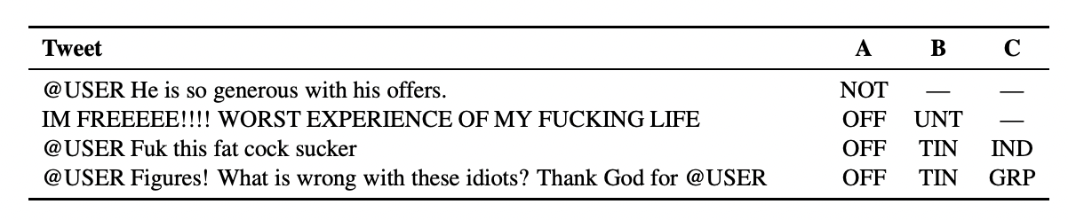  
 Table 1: Four tweets from the dataset, with their labels for different sub-tasks

**Sub-Task A:**

Within this sub-task, we are interested in identifying offensive posts and posts containing any form of untargeted profanity. Within this sub-task, there are two categories in which the tweet could be classified:

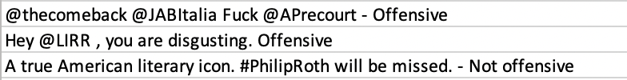

Table 2: Example of Tweets from **Sub-Task A**

***Not Offensive: (NOT)***

A category that contains posts that do not contain abusive content or profanity.

***Offensive: (OFF)***

A category that contains offensive language or targeted offence. This category can include insults, threats and posts containing hateful speech.

**Sub-Task B:**

Within this sub-task, we are interested in categorizing offences. Tweets are labelled between one of the following categories:

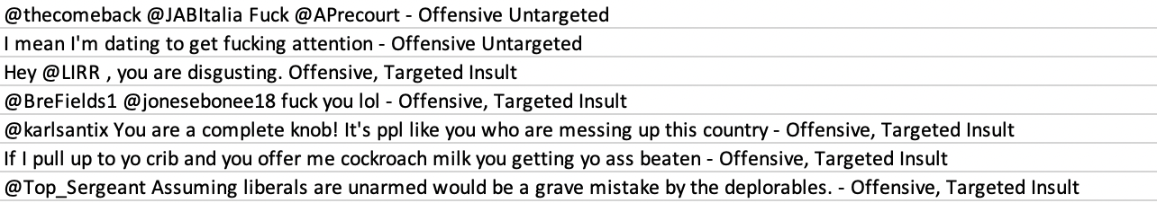

Table 3: Example of Tweets from **Sub-Task B**

***Targeted Insult: (TIN)***

A post is containing an insult or a threat to an individual group or others.

***Untargeted: (UNT)***

A post is containing non-targeted profanity and swearing.

**Sub-Task C:**

Within this sub-task, we are interested in the target of offences. Only posts which are either insults or threats are included within this sub-task. The posts are placed among the following three categories:

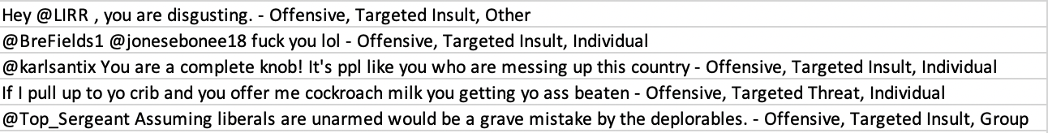

Table 4: Example of Tweets from **Sub-Task C**

***Individual: (IND)***

The target or the offensive post is an individual: a famous person named individual or an unnamed person interacting in the conversation.

***Group: (GRP)***

The target of the offensive post is a group of people considered as a unity due to the same ethnicity, gender or sexual orientation, political affiliation, religious belief or something else.

***Other: (OTH)***

The target of the offensive post does not belong to any of the previous two categories (e.g., an organization, a situation, an event, or an issue) [(Zenaty, 2019)](https://www.aclweb.org/anthology/S19-2144/)

## 2.3 OLID 2019 Dataset

The Offensive Language Identification Dataset **(OLID)** dataset contains a collection of **14,100** annotated English tweets using an annotation model that encompasses the following three levels:

* A: Offensive Language Detection
* B: Categorization of Offensive Language
* C: Offensive Language Target Identification

Out of the **14,100** annotated English tweets, **13,240** tweets have been provided as the **Training Data**, and **860** tweets have been provided as the **Testing Data.**Each tweet within the **Training Dataset**has an **ID**, **Tweet**and **Corresponding Labels**for its **Sub-Tasks.**

**OLID** was the official dataset used in the OffensEval: Identifying and Categorizing Offensive Language in Social Media (SemEval 2019 – Task6). [[1]](https://sites.google.com/site/offensevalsharedtask/olid)

While there are platforms like [**Kaggle**](https://www.kaggle.com/)and [**TrackMyHashtag**](https://www.trackmyhashtag.com/)that provide large datasets to conduct sentimental analysis on **Tweets;**to maintain uniformity against the results produced previously for this particular task, we must use the **OLID**dataset from OffensEval.

The **OLID** dataset has been investigated previously by a large number of university students ranging from **Imperial College London (UK)** to **The University of Arizona (USA).** In the below section we would be highlighting upon the general approaches used in solving the problem.

## 2.4 Data Pipeline

**Data**is the core asset of every business, project or organisation in today’s world. However, vast amounts of information are being produced in different formats leading to the **Processing, Storing**& **Migration of Data**becoming complex. The most optimal solution to counter the complexity is to introduce a **Data Pipeline,**which would help provide solutions to the complications mentioned above.

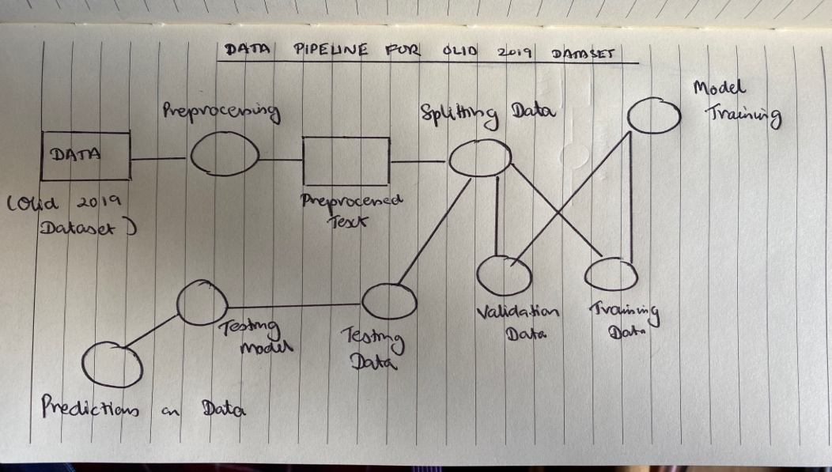

[Figure 1.6: High-Level Overview of our Data Pipeline](https://hazelcast.com/glossary/data-pipeline/)

The **Data Pipeline**implemented would consist of the following steps:

1. Data Pre-Processing
2. Splitting of Data into Training & Testing Set
3. Training of our Machine Learning Model
4. Modification of Parameters for Improved Results
5. Build on the **ML**model to make predictions on Test Dataset

An in-depth description of the above steps within our **Data Pipeline**is described in **Chapter 3: Proposed Approach, sub section 3.4: Pre-Processing of Dataset.**

## 2.6 Evaluation Metrics

To evaluate the performance of the proposed Machine Learning venture, the official metric used in the **SemEval 2019 Competition**was the averaged **Macro F1-Score**across the different **Sub Tasks A, B & C.** The **SemEval2019 Competition**proposed the averaged **Macro F1-Score** across the above tasks because of the varying and irregularity of instances of tweets across the **OLID 2019 Dataset**.

### 2.6.1 Precision

**Precision** is essentially a measure of how often a particular sentiment rating or label was correct. It aids in evaluating how specific a model is in predicting positive labels. The metric also helps answer the question as to how often our model predicts positive labels?

The formula for **Precision** is provided below:

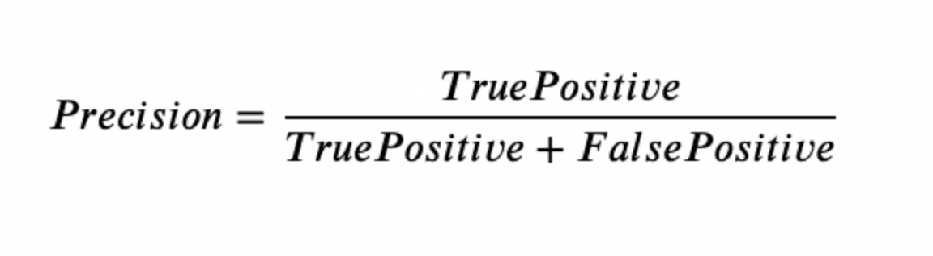

[Figure 1.7: Formula of Precision](https://medium.com/@erika.dauria/accuracy-recall-precision-80a5b6cbd28d)

### 2.6.2 Recall

**Recall** helps in calculating the percentage of actual positives our model correctly identifies (True Positives).

The formula for **Recall** is below:

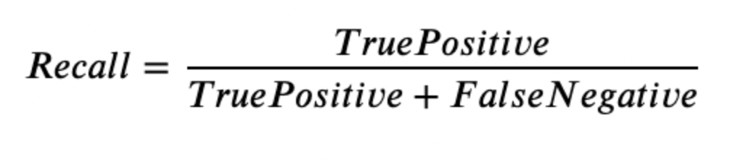

[Figure 1.8: Formula of Recall](https://medium.com/@erika.dauria/accuracy-recall-precision-80a5b6cbd28d)

### 2.6.3 Macro F1-Score

**Macro F1-Score** aids in calculating the harmonic mean for **Precision** and **Recall.** The Macro F1-Score lies in the range of 0.0-1.0 where1.0 would be perfect. The **Macro F1-**Score metric is extremely helpful since it gives us a single metric capturing two different aspects i.e., **Precision** and **Recall**.

The formula for **F1-Score** is below:

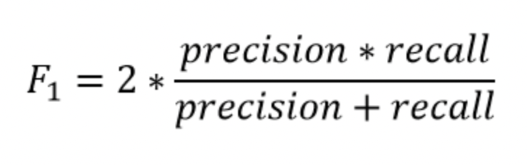

[Figure 1.9: Formula of F1-Score](https://medium.com/@erika.dauria/accuracy-recall-precision-80a5b6cbd28d)

### 2.6.4 Accuracy

**Accuracy** is an evaluation metric that aids in measuring the total number of predictions our model gets right.

The formula for **Accuracy** is below:

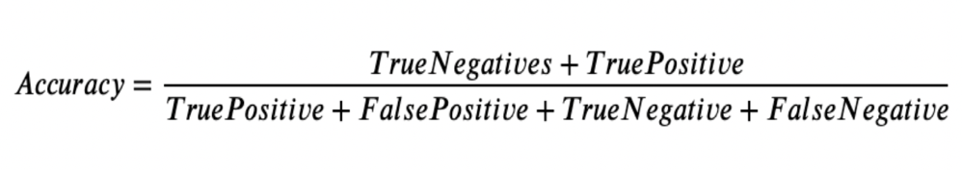

[Figure 1.10: Formula of Accuracy](https://medium.com/@erika.dauria/accuracy-recall-precision-80a5b6cbd28d)

Since the **Macro F1-Score**captures both **Precision**and **Recall,**we would be focusing our efforts on comparing the outcomes of our models using **Accuracy**and **F1-Score,**enabling us to streamline our

process of evaluating our models.

## 2.7 Previous Approaches & Strategies Implemented from Literature

This section provides a high-level overview of the general **Machine Learning (ML)**and **Deep Learning (DL)**techniques applied previously by different researchers and universities, along with participants from the **OffensEval 2019 Competition.**We also present detailed descriptions of some of the best techniques implemented alongside our baseline recommendations.

Many research projects have been carried out previously to address the offensive content and hate speech prevailing on social media websites. [(Salminen, Sengün, Corpan, Jung, J.Jansen, 2020)](https://journals.plos.org/plosone/article?id=10.1371/journal.pone.0228723) Researchers at **Cambridge University**have proposed strategies to tackle hateful and distasteful content using a **"Quarantined"**approach to combat malicious software.

[(University of Cambridge, 2019)](https://www.cam.ac.uk/research/news/online-hate-speech-could-be-contained-like-a-computer-virus-say-researchers)

The very definition of **Hate Speech**varies depending on the social media platform it is used in. Blocking keywords containing abuse or offensive content would be ineffective because the entire context of the sentence would not be analysed. To combat these challenges faced by social media platforms, a variety of widespread **Machine Learning**techniques have been implemented.

These are:

### 2.7.1 Logistic Regression

**Logistic Regression** is a traditional technique used in both **Statistical** and **Machine** **Learning** problems. In simple terms, **Logistic** **Regression** is similar to **Linear Regression,**except **Logistic Regression**helps in predicting if something is **True**or **False**instead of predicting a continuous variable like **Size.**

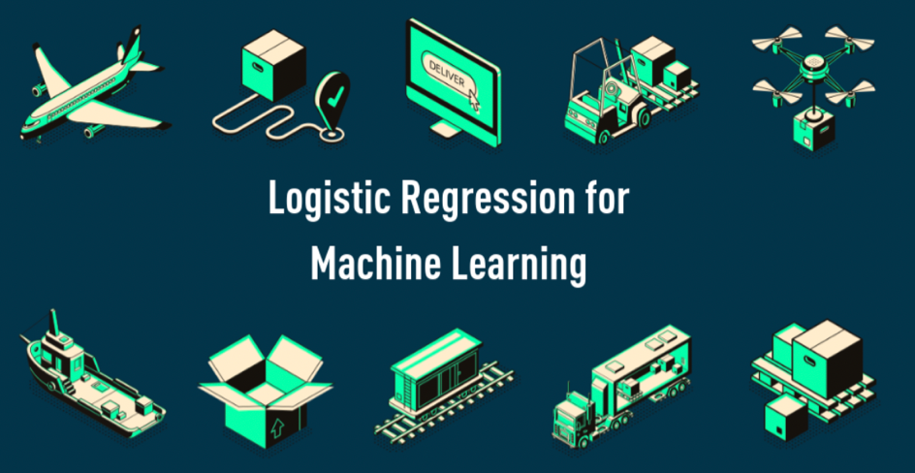

[Figure 1.11: Logistic Regression is Renowned for ML Problems](https://kambria.io/blog/logistic-regression-for-machine-learning/)

**For Example:**

If we were to use a **Logistic Regression**classifier on our **Sub-Task A** from **SemEval Task-6**of detecting if a post or tweet is **Offensive (OFF)**or **NOT OFFENSIVE (NOT OFF)**, it would be an instrumental technique.

Additionally, within **Logistic Regression,**we can build models with several different variables that include both **Continuous**and **Discrete Data.**The ability to provide probabilities and classify new datasets using continuous and discrete measurements makes it a popular **ML**technique when detecting offensive language in social media. On reviewing and investigating previous research papers, professors and PhD students at **The Hong Kong University of Science & Technology** have greatly advocated for **Logistic Regression** in tackling **Offensive Language.** [(Ho Park & Fung, HKUST, 2017)](https://arxiv.org/pdf/1706.01206.pdf)

Although **Logistic Regression** has received tremendous support in detecting offensive language for **Sub-Task A** owing to its **Macro F-1 Score** of **0.9**; it only received a **Macro F-1 Score** of **0.44** in detecting hate speech. It makes us realise that while **Logistic Regression** can be suitable for one of the **Sub-Tasks** from **SemEval 2019**; it cannot be used universally for all challenges of classification. [(Gabriel, 2020)](https://shura.shu.ac.uk/26018/1/IEEE_WCCI_Artificial_Intelligence.pdf)

### 2.7.2 Support Vector Machines

The **Support Vector Machines (SVM)**is another prominent **ML**algorithm used in classification and detection problems. It is a highly recommended **ML**technique because of its high accuracy with less computational power and widely accepted in both industry and academia. It is a form of **Supervised Machine Learning**that analyses data and sorts it into our defined set of classes.

**For example:**

If we were to use an **SVM**in our exploratory venture within either **Sub-Task B**or **Sub-Task C** from **SemEval Task-6**, it would be remarkably advantageous in categorising the offensive content into our established set of categories.

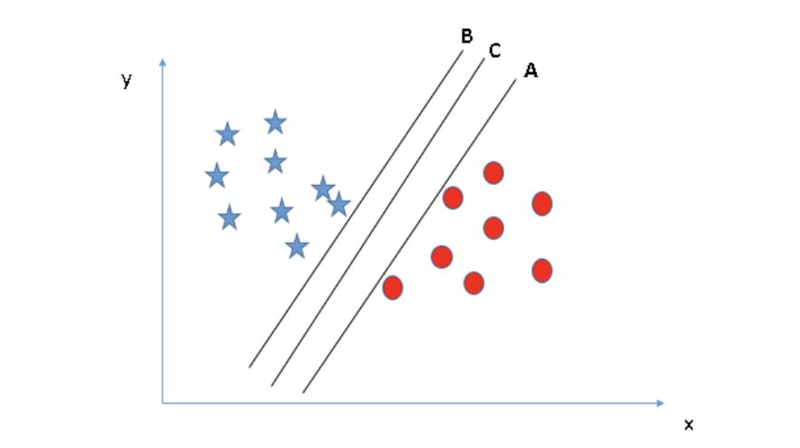

A & B are **Support Vectors**

C is the **Dividing Hyperplane**

[Figure 1.12: An SVM Graph Classification](https://www.analyticsvidhya.com/blog/2017/09/understaing-support-vector-machine-example-code/)

On critiquing former research papers, it was found that many leading universities across the globe, including but not limited to India [(Patra & Das, Jadavpur University, 2016)](https://www.aclweb.org/anthology/S16-1071.pdf) and The United States of America [(Zhu, Tian & Kubler, University of Michigan, 2019),](https://arxiv.org/pdf/1904.03450.pdf) supported the implementation of **SVM's.**Additionally, a **Linear SVM** trained specifically on word unigrams has achieved **State-of-the-Art** results for many classificational tasks. [(Zampieri, 2018)](https://arxiv.org/pdf/1902.09666.pdf#page=6&zoom=100,404,213)

Whilst **Support Vector Machines**have been greatly promoted due to its incredibly high **Macro F1-Score**of **0.91**, the classification technique did not produce substantial results for hate speech detection. A shortcoming we also noticed in **Logistic Regression.**[(Gabriel, 2020)](https://shura.shu.ac.uk/26018/1/IEEE_WCCI_Artificial_Intelligence.pdf)

2.7.3 Naïve Bayes Classifier

Another widely accepted classification technique used within **ML**is a **Naïve Bayes Classifier.**

A **classifier**is essentially a **Machine Learning**model used to discriminate and differentiate objects based on certain features. A **Naïve Bayes Classifier**is a **Supervised Machine Learning Algorithm** based on the preceding principle, but the core of its classification is based upon **Bayes Theorem.**[(Gandhi, TowardsDataScience, 2018)](https://towardsdatascience.com/naive-bayes-classifier-81d512f50a7c)

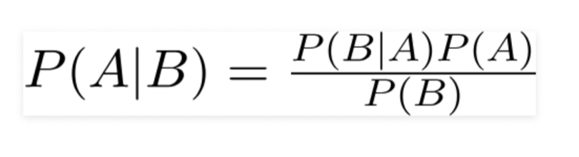  
[Figure 1.13: Formula of Bayes Theorem](https://towardsdatascience.com/naive-bayes-classifier-81d512f50a7c)

**For Example:**

" I look forward to Scotland qualifying for the EURO 2020 Competition.

**#TwitterFamily #ILoveScotland**"

With a **Naïve Bayes Classifier's help,**we can classify a particular tweet based on the various features **('text' or 'words')**used within it. For instance, we could classify the above tweet into a section of **Sports.**This inadvertently would allow many tweets to be further categorised and analysed more optimally. Although there have been many research projects that have supported the use of a **Naïve Bayes Classifier** [(Bhandary, San Jose State University, 2019)](https://scholarworks.sjsu.edu/cgi/viewcontent.cgi?article=1691&context=etd_projects), it has its set of drawbacks as well. The biggest disadvantage being the assumption that all the features (**'text' or 'words')**in a **Tweet**are independent of each other, which doesn't happen in real life.

### 2.7.4 Long Short-Term Memory (LSTM)

Scrutinising and investigating upon the past research papers highlighted the extensive use of models based on **Neural Networks.**A **Neural Network**also referred to as an **Artificial Neural Network,**is a series of algorithms that endeavour to recognize underlying relationships in a set of data through a process that mimics how the human brain operates. An example of an **Artificial Neural Network**model is the **Long Short-Term Memory Network (LSTM).**

Researchers have built upon an existing model present for sentiment analysis. **LSTM,**in simple terms, is a **Recurrent Neural Network.**It means it takes the output from a previous step and combines it with the input for the next step.

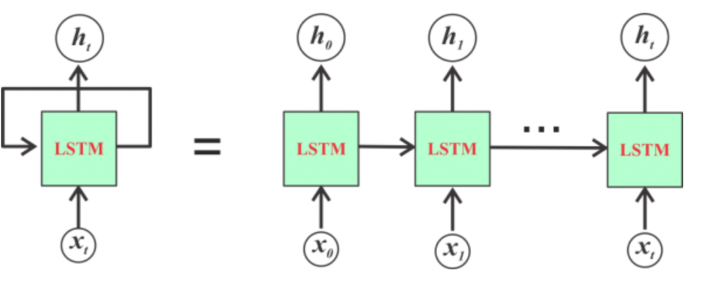

[Figure 1.14: Flowchart of a Simple LSTM Recurrent Neural Network Model](https://www.codeproject.com/Articles/5165357/In-Depth-LSTM-Implementation-using-CNTK-on-NET-Pla)

**For example:**

When analysing our **OLID 2019 Dataset,**we would be feeding the **LSTM**model with a variety of **Tweets**consisting of many features. The output from every **Tweet,**whether it is **Offensive**or **Not Offensive,**will then be fed again to the subsequent **Tweet.**

From previous experimentations and critique, **LSTM**has provided remarkable results with a **Macro F-1 Score**of **0.75,**but the biggest drawback it faces is being prone to overfitting and challenge to solve this concern. [(Zampieri, 2018)](https://arxiv.org/pdf/1902.09666.pdf)

### 2.7.5 Convolutional Neural Networks (CNN)

When studying and analysing previous research projects in **Detecting** **Offensive Language,**another **Neural Network**model has been comprehensively defended. This **Neural Network**model is called a **Convolutional Neural Network (CNN).**

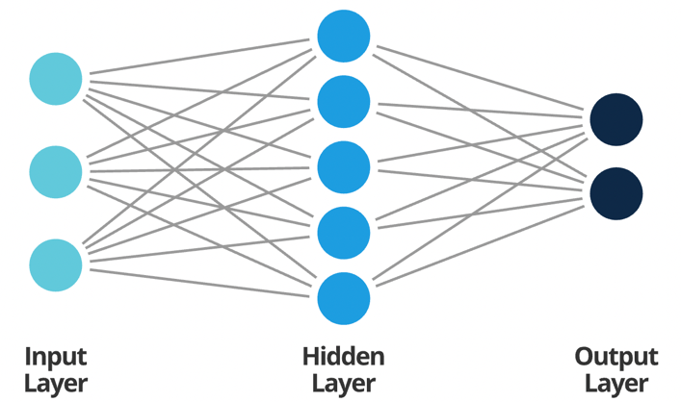

[Figure 1.15: A Neural Network Architecture](https://www.smartsheet.com/neural-network-applications)

Before expanding upon the uniqueness of **CNN,**it is essential to understand what a Neural Network is**.**A simple **Neural Network**consists of an **Input Layer, Hidden Layer**and an **Output Layer.**The **Input Layer**accepts input in different forms; the **Hidden Layer**performs calculations on these inputs. Finally, the **Output Layer**provides the outcome of the analysis and extractions carried out on these inputs. Each of these layers consists of neurons connected to the neurons in the previous layer, with each neuron having its weight. The weighting of every neuron implies that we don't make any assumptions made on the data fed to the neural network. This principle would be beneficial when working on projects that do not involve **Natural Language & Image Processing**challenges.

This is where **CNN**comes into play. **CNN**works unconventionally since they treat data to be spatial. Instead of having neurons connected to every neuron in the previous layer, they are alternatively connected to neurons close to it, with all having the same weight. This simplification within the neural connection results in the network upholding the spatial aspect of a dataset. Furthermore, the word **Convolutional**refers to the **Filtering Process**in such **Neural Networks.**

**For example:**

Hypothetically, we have a tweet that has different characters, images and is highly complex to understand. A **CNN**simplifies it so that it can be better processed and understood.

The comprehensive study from previous research papers has shown the great use of **CNN**in detecting and identifying **Hate Speech.**The primary influence for the application of **CNN**is its ability to see essential features without any human supervision. [(Puiu, Brabete, Imperial College London, 2019)](https://arxiv.org/pdf/1903.00665.pdf)

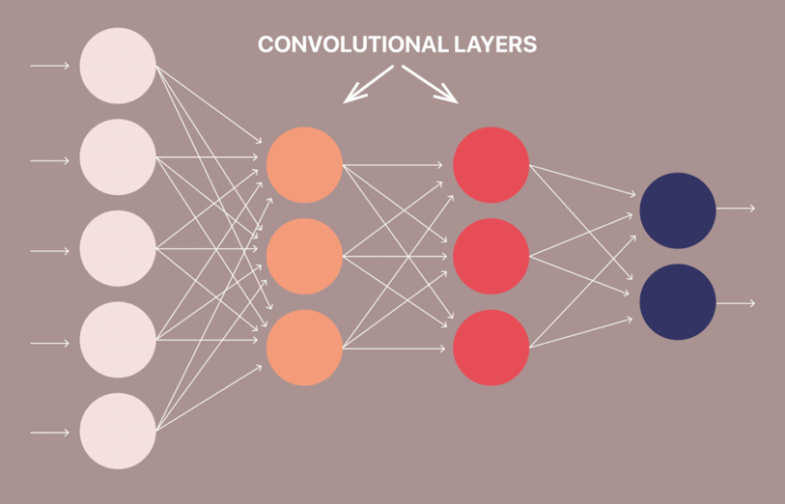

[Figure 1.16: Sample Architecture of a Convolutional Neural Network](https://lionbridge.ai/articles/difference-between-cnn-and-rnn/)

**For example:**

If our **OLID 2019 Dataset**consisted of tweets with pictures of **Dogs**and **Cats,**it would learn the distinctive features of the two classes themselves.

While **CNN** brings an incredible number of benefits, specific characteristics put it at a disadvantage. The major shortcoming is the significant amount of time consumed for training purposes since a **CNN**consists of several different layers. Additionally, for **CNN**to work efficiently, the machine needs to have a potent **GPU** that is not easily accessible.

### 2.7.6 Bidirectional Encoder Representations from Transformer (BERT)

**BERT**is one of the most complex and sophisticated architectures developed by the **Artificial Intelligence**team at **Google.**It is considered the most advanced algorithm for **Natural Language Processing**essentially because of its ability to read text from both directions, left to right as well as right to left. This invariantly leads it to get the name **Bidirectional. BERT**comprises a unique architecture within itself by deploying an **Encoder-Decoder**mechanism for carrying out **NLP**tasks. This mechanism is represented by a **transformer that is represented by Recurrent Neural Networks** in other machine learning algorithms**.**

Owing to its state-of-the-art results, most teams have used a fine-tuned version of the **BERT**architecture to gain a better **Macro F1-Score.**Although **Google's BERT**is considered the best model for **NLP**tasks; improvements and precise tuning are still being carried out to improve results. [(Zampieri, 2018)](https://arxiv.org/pdf/1903.08983.pdf)

2.8 Baseline Approaches to Problem

After extensive review and examination from previous research papers and **NLP**projects carried out; for our exploratory venture, we have decided to implement two **Baseline Methods:**

1. **Logistic Regression Classifier**
2. **Convolutional Neural Networks**

An in-depth description and justification of our baseline methodologies is provided within **Chapter 3: Proposed Approach,** sub section **3.1: Innovative Strategy Aimed.**

3. Proposed Methodology

Through the third chapter, we aim to describe the recommended methodologies and the justification behind them. Furthermore, we provide an in-depth description of the adopted dataset and the specific pre-processing steps. Apart from our aimed baselines, we provide additional information on potential baseline techniques that could have also been performed. Lastly, a complete account of the parameters and evaluation metrics deployed has been provided.

3.1 Innovative Strategy Aimed

After a comprehensive analysis and evaluation of the preceding approaches present within the domain of **Hate Speech Identification**, we have decided to implement two **Baseline Methodologies.**These are, namely, **Logistic Regression**& **Convolutional Neural Networks.**The primary aim of our exploratory venture is to replicate the results obtained by the afore-mentioned baselines.

The uniqueness and innovativeness of our investigation and analysis is because of:

1. Improved Pre-Processing techniques deployed on the **OLID 2019 Dataset**
2. Synthesis and Unification of implemented algorithms and **Deep Learning**models to achieve a better **Macro F1-Score.**
3. **Meticulous and Precise evaluation of Metrics captured while training different Machine Learning and Deep Learning models on amended parameters.**
4. **Implementation of Glove Embedding (100d & 200d) for obtaining vector representations of words in tweets.**
5. **Executing One-Hot Encoding to process categorical features of our ML model.**

Whilst previous research papers and projects have practised a variety of **ML**techniques, the common similarity possessed within them is the inclusion of **BERT**in it. [(Tawalbeh, Hammad, AL-Samadi, 2020)](https://arxiv.org/pdf/2005.07820.pdf)

Since **BERT**is the state-of-the-art model and provides significantly outstanding results and outcomes, a significant proportion of **Universities**and **Research Groups**inevitably implement the **BERT**model.

[(Aggarwal, Horsmann, Wojatski, Zesch, 2019)](https://www.aclweb.org/anthology/S19-2121.pdf)

However, after close examination and analysis of results produced, it has been observed that professors from renowned universities have strongly advocated the use of **Logistic Regression**in the domain of **Sentimental Analysis**and **Natural Language Processing.**[(Mitrović, Birkeneder, Granitzer, 2019)](https://www.aclweb.org/anthology/S19-2127.pdf). This is mainly because of its simple implementation, effective method of training and precision in classification. Since a majority of the **Sub-Tasks**involve classification and sorting, **Logistic Regression**would be a key methodology in improving upon the **Macro F1-Score.** [(Ramdhan, Novianthy, Casi, 2017)](https://ieeexplore.ieee.org/abstract/document/8226700)

Furthermore, an in-depth investigation of past research projects has provided insight into the widespread usage of **Convolutional Neural Networks. CNN** isn't just being used for classification within the **SemEval 2019 Competition**but has also been deployed by social networking sites like **Facebook.**

The primary reason behind the extensive acceptance of **CNN**is the automatic detection of relevant **features**from a text, image or video and the remarkable outcomes captured. This method of detection and learning is called **Feature Learning.** [(Liao, Wang, Yu, Sato, Cheng, 2016)](https://reader.elsevier.com/reader/sd/pii/S1877050917312103?token=A3915588DBB28B8DDE225A712D7C25D202237A9CA510B86C50AAC539B6517726E2AB5ACA03351E2B791FC53ADBB8DD78)

Additionally, for distinct tasks, **CNN**is an extremely useful **Feature Extractors.**This implies that useful attributes and characteristics can be extracted from a previously trained **CNN**with its trained weights by feeding the **OLID 2019 Dataset**on different levels and tuning the **CNN**for a specific task. [(Mitrović, Birkeneder, Granitzer, 2019)](https://www.aclweb.org/anthology/S19-2127.pdf).

**For Example:**

If a tweet consisted of an offensive face, we as human beings would be able to located and detect it. In a **CNN**, this ability or characteristic has to be encoded, which would allow it to extract similar features of an **offensive**face regardless of how they are portrayed.

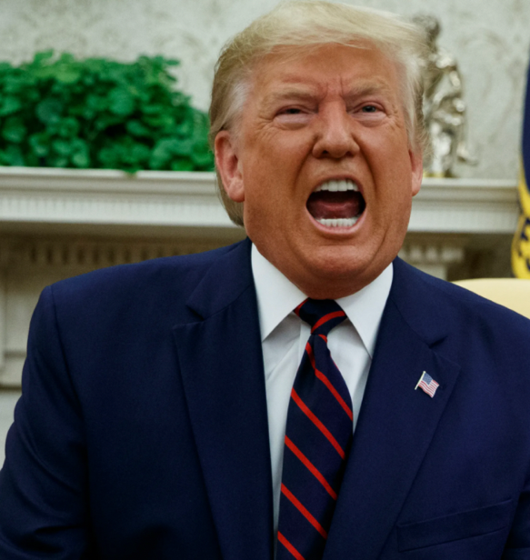

[Figure 1.17: Example of a person showcasing hate can be captured by **CNN**](https://www.google.com/search?q=angry+trump&tbm=isch&ved=2ahUKEwjc7qixgMXvAhVF2xoKHXpQDsIQ2-cCegQIABAA&oq=angry+trump&gs_lcp=CgNpbWcQAzICCAAyAggAMgIIADICCAAyAggAMgIIADICCAAyAggAMgIIADICCABQtFdY2ltg1F1oAHAAeACAAUaIAbYCkgEBNZgBAKABAaoBC2d3cy13aXotaW1nwAEB&sclient=img&ei=aiFZYNyROsW2a_qguZAM&safe=strict#imgrc=KvN5YW3GahxVSM)

3.2 Adopted Dataset

The primary dataset implemented to train our model is the **OLID 2019 Dataset**(SemEval 2019). The **OLID 2019 Dataset**has been annotated hierarchically to classify tweets for three **Sub-Tasks:**

1. If the tweet is **Offensive (OFF)**or **Not Offensive (NOT)**
2. If the tweet has been a **Targeted Insult (TIN)**or an **Untargeted Insult (UNT)**
3. If the tweet has targeted a particular **Individual (IND), Group (GRP)**or **Other (OTH)**

To receive an optimal and accurate outcome for a **CNN**, it is vital to feed it with large volumes of training data. An attempt was made to feed the **CNN**model with a **Hate Speech Dataset** from **Data. World**[(Thomas Davidson, Dana Warmsley, Michael Macy, and Ingmar Weber, 2017)](https://data.world/crowdflower/hate-speech-identification) and **Twitter Sentimental Analysis Dataset**from **Kaggle**for the [Toxic Comment Classification Challenge](https://www.kaggle.com/vkrahul/twitter-hate-speech/code)**.**The addition of both these datasets was not helpful in either increasing the **Macro F-1 Score**or the **Precision**; however, there was an increase in **Accuracy**by ~ **3%. Therefore, in order to train our ML and DL models, we would be concentrating our focus on the OLID 2019 Dataset.**

On retrieving, the **OLID 2019 Dataset** from **Twitter**using its **Application Programming Interface (API), we** search for keywords that are often included in offensive languages. A sample list of keywords has been provided in the table below:

|  |  |
| --- | --- |
| **Keyword** | **Offensive %** |
| Gun Control | 34.7 |
| Antifa | 26.7 |
| MAGA | 27.7 |
| Liberals | 38.0 |
| Conservatives | 23.3 |
| Safe | 58.9 |
| He is | 32.4 |

[Table 5: Keywords Used when Annotating the dataset along with their percentage of Offensiveness](https://www.aclweb.org/anthology/N19-1144.pdf)

In their research paper, [(Zampieri, Malmasi, Nakov, Rosenthal, Farra & Kumar,2019)](https://www.aclweb.org/anthology/N19-1144.pdf) initiated a trial annotation of **300** instances with **six**experts using **nine**keywords. The purpose of the trial annotations was:

1. To Evaluate the proposed target
2. To Evaluate the data retrieval method
3. To create a gold standard with instances that could be used as test questions to ensure the quality of annotators for the entire dataset carried out by using **Crowdsourcing**

Different annotation strategies had been implemented to classify the distribution of **Offensive Tweets,**and the most recommended approach was to exclude **keywords**not high in **Offensive**content during the trial annotations. Additionally, to normalise and anonymise the **Tweets,**there was no storage of any user **Metadata**or **Twitter ids. Twitter**mentions had been substituted by placeholders. To have a much more robust annotation, the researchers decided to seek political keywords as they tended to be richer in **Offensive**content and **Hate Speech.**The **OLID 2019 Dataset**subsequently was sampled in such a manner that **50%**of the Tweets came from **Political Keywords,**and the remaining **50%**came from **Non-Political Keywords.**[(Zampieri, Malmasi, Nakov, Rosenthal, Farra & Kumar,2019)](https://www.aclweb.org/anthology/N19-1144.pdf)

Multiple annotators have carefully annotated every instance in the OLID 2019 Dataset, and an inter-annotator agreement was calculated at the end. Only, in a case of disagreement, was a third annotation requested, and a majority vote was taken. Furthermore, the **OLID 2019 Dataset**has been built following the prior research carried out by [Burnap and Williams, 2015](https://onlinelibrary.wiley.com/doi/epdf/10.1002/poi3.85) and [Davidson,2017](https://arxiv.org/pdf/1703.04009.pdf).

3.3 Pre-Processing of Dataset

The **OLID Dataset**used in our exploratory venture consists of tweets with characteristics that can be laborious to interpret when applying a **Machine Learning Algorithm**to process it. These characteristics include spelling errors, unconventional and casual language, emojis, special characters and grammatical mistakes. Therefore, it is incredibly vital to implement and process our **Data Pipeline**in the right manner before we apply our **ML Models**and **Classification Techniques**to it. In the below sections we provide an in-depth overview of the steps implemented in our **Data Pipeline**:

**Lowercasing of Tweets:**

Within Twitter, users can tweet with words either **Capitalised or Not Capitalised.**A report from Twitter highlighted that majority of the tweets that contained an extensive sequence of **Capitalised Text**either promoted profanity or consisted of hate speech. By lowercasing all the tweets, we would essentially be **Capitalising over Capitalisation of Text.** By implementing the above pre-processing method, we would strengthen our model and allow it to treat all tweets identically.

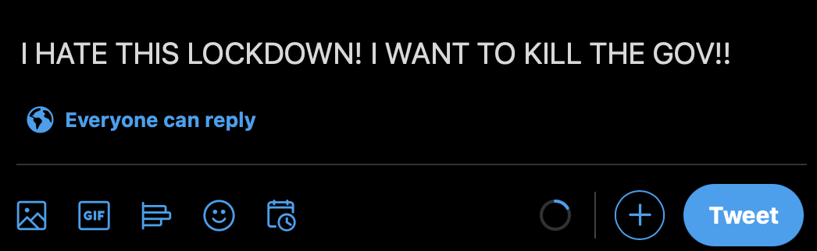

Figure 1.18: Example of a Tweet written in Upper Case

**Converting Contractions to Expansions:**

Since users on Twitter are allowed to express their emotions with a minimal number of characters, they tend to use abbreviated or contracted words. As human beings, we are aware of these contracted words' meanings in contrast to a machine.

For instance, a machine would treat **we're**, and **we are**as two completely different words. The method to expand the contracted terms would inevitably increase the accuracy of our task and allow the machine to provide efficient results. Additionally, executing contractions to expansions reduces redundancy within our dataset and makes our code computationally cheaper.

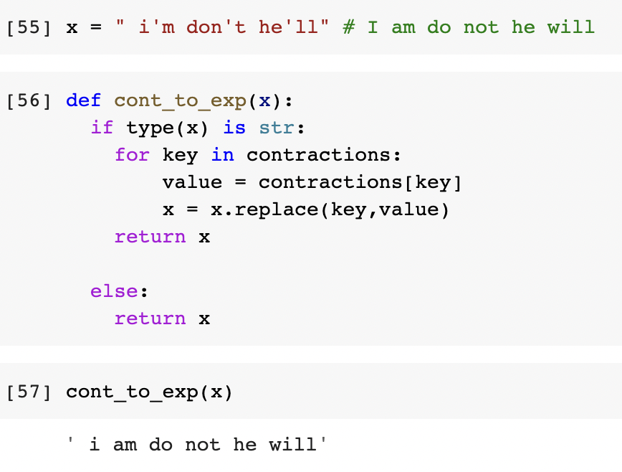

Figure 1.19: Source Code of Converting Contracted Words to Expanded Words

**Removal of Instances of @USER and URL:**

Within Twitter, users can quote **URLs** and tag different **users**. The URL's and mentioning of users would only slow the detection and identification process as they have been anonymized in **OLID 2019 Dataset**. Since our goal is to identify offensive text ,eliminating all instances of @USER tags and URLs would optimise our model.

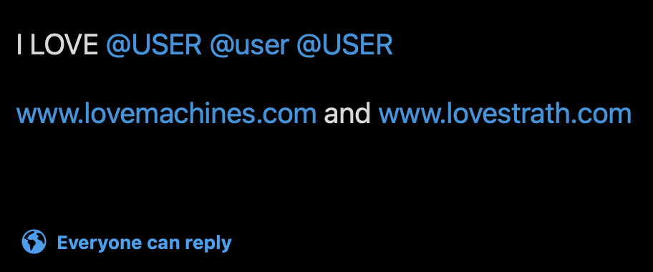

[Figure 1.20: Example of a tweet containing User & URL mentions](http://www.twitter.com/)

**Emojis:**

Emotions and feelings to be perceived have become more critical than ever. Since its inception, Emojis form a significant part of social media conversation, tweets or posts. With the evolution of Social Media, users have learnt to use certain specific emojis that promotes abuse, harassment and abuse. The majority of emojis do not represent a distinct feeling, but a selected few can either infuriate or oppress a particular user.

After carrying out a qualitative analysis of a certain sample of tweets, we target our efforts on only a certain number of emojis that occur frequently and replace it with the **Emoji Dictionary** compiled. This technique would not only aid in our classification and detection process but also allow our model to capture the context of a particular tweet.

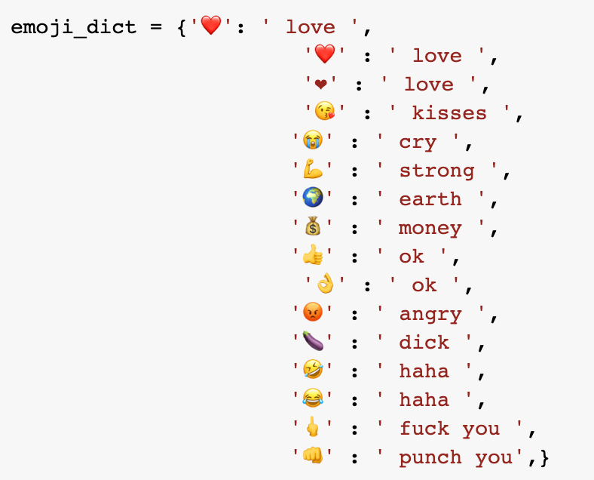

Figure 1.21: Emoji Dictionary of Words That Provides Profanity

**Removal of Special Characters:**

A special character is essentially a character that is not **Alphabetic**or **Numeric.**Punctuation marks and other symbols are examples of special characters. Unlike alphanumeric characters, special characters may have multiple uses, from linking to web pages to quoting references.

For our pipeline, we will remove most of the special characters except:

**(Dots, Punctuation Marks, Exclamation Marks & Question Marks)**.

The justification for the following exception is the frequency with which they are used in everyday language. Additionally, profanity can be promoted using the above special characters.

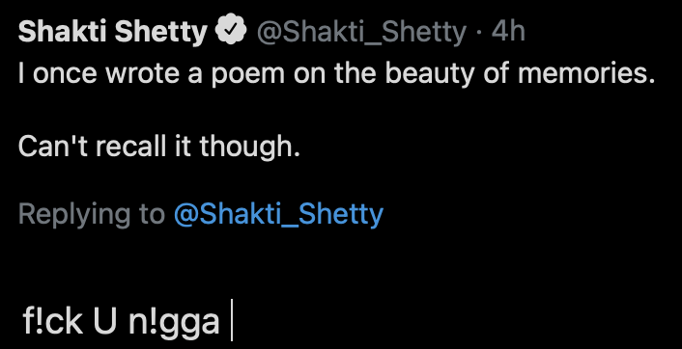

[Figure 1.22: Example of a Tweet](https://www.twitter.com/) containing Special Characters

**For Example:**

**nigger** can be written as **n!gga by using (!) the exclamation mark special character.**

By keeping only certain special characters, we would make our model more robust and accurate, leading to a smaller prevalence of hate speech.

**Removal of Multiple Spaces :**

When using social media platforms, users can implement multiple spaces between their words and sentences. These uneven spaces can make the task of reading the tweet extremely laborious for our **ML**model. To improve efficiency, reduce consumption of time, and increase inaccuracy, we have decided to eliminate the redundant use of multiple spaces.

**For example:**

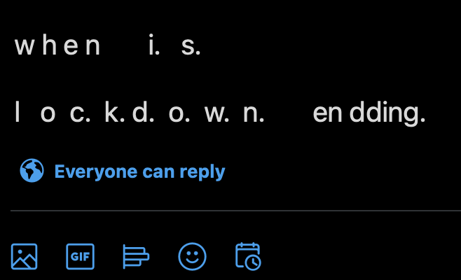

[Figure 1.23: Example of a Multiple Spaced Tweet](http://www.twitter.com/)

**Stemming of Tweets :**

In the English language, a particular word can be portrayed in different manners. As a human being, we understand the concept of **Past**, **Present** and **Future**. However, a machine wouldn’t understand the similar context a word could be implemented.  
To combat this problem, the method of **Stemming** plays a vital role in sentiment analysis. Stemming is mainly used to reduce the dimensionality of data. In simple words, if we have words like walk, walks, waited, waiting that are different but similar contextually, Stemming will remove the suffixes and bring them to their base word ‘walk’.

**For example:**

If there is a tweet that says, “I will be **walking** towards Livingston Tower and stop my **walk** there.”

**Stemming** would take the words **walking** and **walk** and bring it to their base word by removing the suffixes.

**Tokenisation:**

Once the above pre-processing steps have been applied, the text present within each tweet is broken down into smaller units such as individual words or terms. Each of these words is then associated with a numeric vector called **Tokens.**These **Tokens**help in interpreting the true meaning of a sentence by analysing the sequence of words or, in this case, numeric vectors.

Within this section, we provide a small example of how a tweet would be processed once the above techniques have been applied. The example tweet provided below highlights all the problems mentioned above.

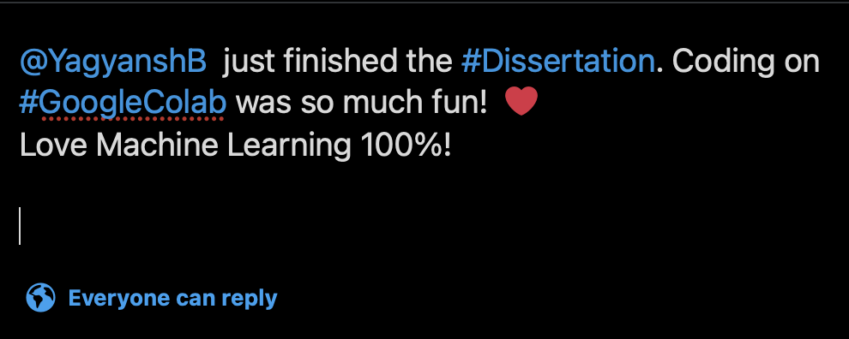

[Figure 1.24 Example of a tweet](https://www.twitter.com/)

Once we have applied our pre-processing techniques, we would obtain the following output:  
***<YagyanshB> just finished the Dissertation Coding on Google Colab was so much fun ! Love Machine Learning 100***

3.4 Splitting of Dataset

To measure the robustness of our **ML**model, it is essential to split our **OLID 2019 Dataset**into **Training Data**and **Testing Data.**The majority of research projects and previous approaches have kept an **eighty-twenty**split between **Training Data**and **Testing Data.**The primary motivation behind splitting datasets is to restrict the model from overfitting and rigorously evaluate it.

The **OLID 2019 Dataset** consists of **14,100** tweets, of which **13,240**tweets have been provided as **Training Data.**The remaining **860**tweets have been provided as**Testing Data.**Additionally, on further investigation and study, it is found that each tweet within the dataset has an **id** and corresponding **label** for each **subtask**.

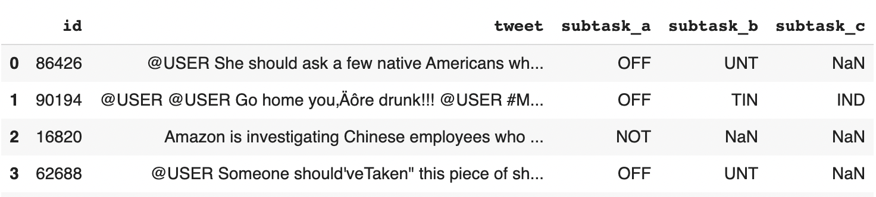

[Figure 1.25: Sample tweets from the training dataset](https://colab.research.google.com/drive/1tn1VGJF2kNqQcRlmvzvy3VORDbn9uMU3#scrollTo=hdxDsY-KcxeX)

Furthermore, the **Training & Testing Dataset** distribution for each of the different sub-tasks has been provided below.

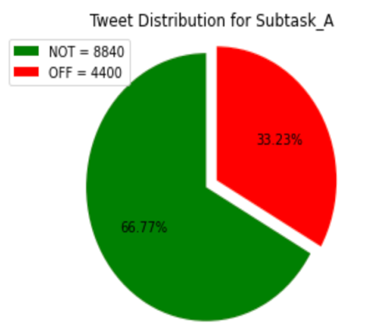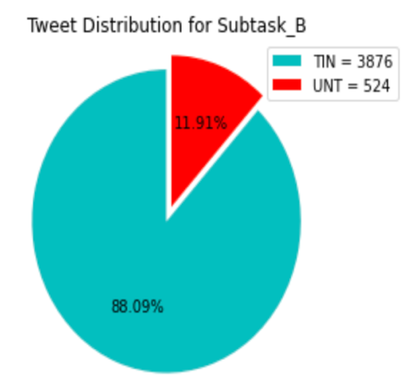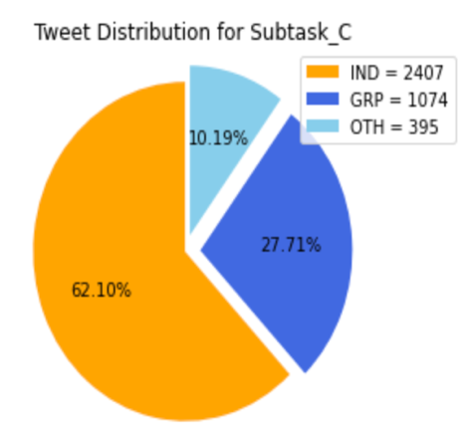

[Figure 1.26: Data Distribution of Training Dataset for different subtasks](https://colab.research.google.com/drive/1tn1VGJF2kNqQcRlmvzvy3VORDbn9uMU3#scrollTo=hdxDsY-KcxeX)

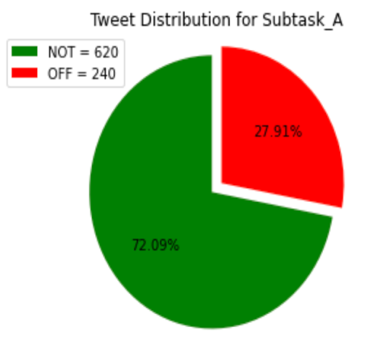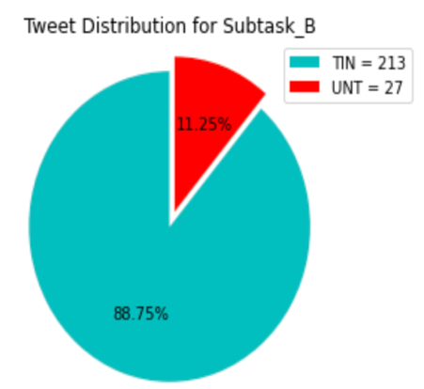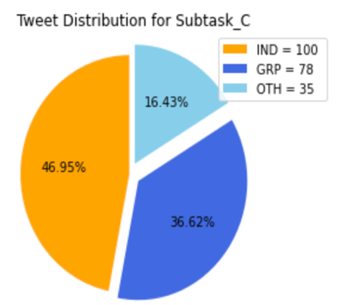

[Figure 1.27: Data Distribution of Testing Dataset for different subtasks](https://colab.research.google.com/drive/1tn1VGJF2kNqQcRlmvzvy3VORDbn9uMU3#scrollTo=hdxDsY-KcxeX)

The **OLID 2019 Dataset**has been annotated using the **Figure Eight Labelling Crowdsourcing Platform.**[(Figure Eight)](https://aws.amazon.com/solutionspace/financial-services/solutions/figure-eight/)

Moreover, we split our **Training Dataset**into a **Training**and **Validation Dataset.**The main goal to split our dataset into a **Validation Dataset**is to provide an unbiased evaluation of our model on the training dataset while fine-tuning our model parameters. For our **ML**project, we set the **Validation Dataset**to be **10%**of the **Training Data**provided

3.5 Distinctive Methods Implemented

After a thorough analysis and research, we have decided to deploy two baselinemodels for our exploratory venture. Following an evaluation of over seven different **Hate Speech & Offensive Language Detection** studies, **CNN**is arguably the most suitable technique for classification.

Additionally, it has also been observed that **Logistic Regression**has been one of the go-to methods in carrying out **Classification**tasks for the **OLID 2019 Dataset.**

The distinct characteristics of our implementations for our **Baseline Models** lie in the addition of features like **Glove Vector Embeddings**and **One-Hot Encoding**on the **OLID 2019 Dataset.**

The **Glove Vector Embeddings**are available in several versions **(50d, 100d, 200d and 300d)**, but we would implement **100 dimensions**and **200 dimensions**vectors for our exploratory project. Experimentations were carried out with smaller and higher dimensions embeddings, but the results did not outperform our implemented **Glove Vectors**of **100d**and **200d**.

[(Pennington, Socher, Manning, Stanford University)](https://nlp.stanford.edu/pubs/glove.pdf)

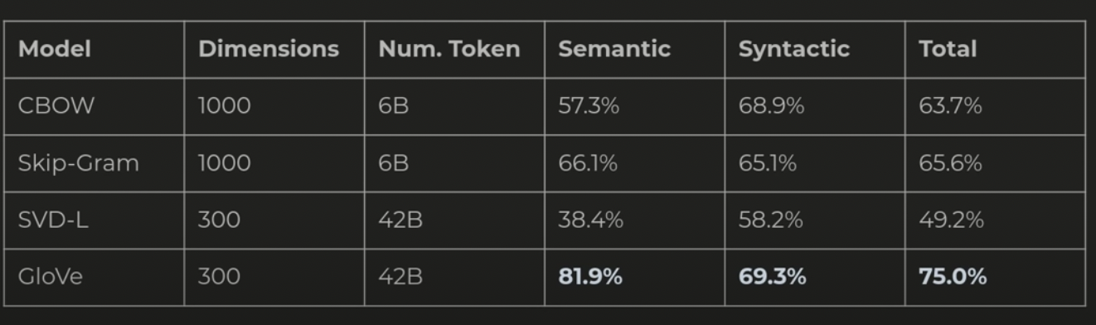

[Figure 1.28: GloVe Vector Embeddings Performance on World Analogies Dataset](https://aclweb.org/aclwiki/Google_analogy_test_set_(State_of_the_art))

The second defining feature for our **Baseline Model**is the deployment of **One-Hot Encoding**vectors on the **OLID 2019 Dataset**when performing the **Logistic Regression**model. Since our dataset consists of categorical labels, it contributes to a major constraint when building an **ML**or **DL**model. Many **ML**algorithms cannot work directly on labelled data and require them to be converted to numerical data; by implementing the **One-Hot Encoding**vectors on our dataset, we would optimise the process and allow the machine to run at a faster clock rate. [(Mastering Machine Learning, 2017)](https://machinelearningmastery.com/why-one-hot-encode-data-in-machine-learning/)

The primary purpose of adding these features is to improve **Accuracy & Precision,**resulting in a higher **Macro F1-Score.** A detailed description of our distinguished features is provided in **Chapter 4.3: Important Characteristics and Features.**

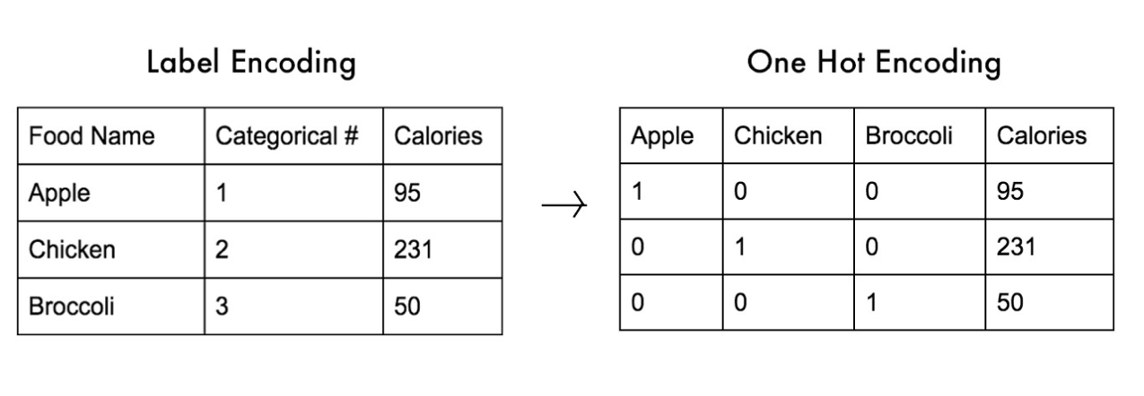

[Figure 1.29: Converting Labelled Words to One Hot Encoded Vectors](https://medium.com/@michaeldelsole/what-is-one-hot-encoding-and-how-to-do-it-f0ae272f1179)

3.6 Additional Baseline Performed

For any **ML** project, it is imperative to perform multiple baselines. The two main reasons behind this are the constant shift in project scope and novel features that produce better results than our executed **Logistic Regression**and **Convolutional Neural Networks**models.

To combat such limitations, we have decided to implement additional baseline techniques such as a **Support Vector Machine (SVM)**model and a **Random Forest Classifier**.

The **SVM**model has been taken into consideration as a supplementary model for two reasons:

1. Background research and analysis of papers advocate **SVM**to be the best linear classification approach.
2. An **SVM**model can be easily converted into a **Non-Linear Classifier.**This means that an **SVM**model contains functions to distinguish different texts or instances not linearly separable.

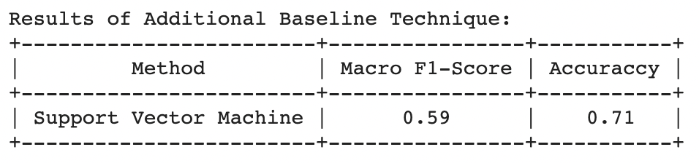

[Figure 1.30: Macro F1-Score Achieved on Implementing SVM Model](https://github.com/YagyanshB/SemEval-Task6-CS408/blob/main/Additional_Baseline_SVM.ipynb)

On implementing the **SVM**technique on our **OLID 2019 Dataset,**we achieved a **Macro F1-Score**of **0.59**.

The **Random Forest Classifier** model has been taken into consideration as a supplementary model for two reasons:

1. Previous papers and research showcase that a **Random Forest Classifier** reduces the overfitting of data and helps in improving accuracy.
2. A **Random Forest Classifier** model is extremely flexible since it can be implemented for classification and regression analysis.

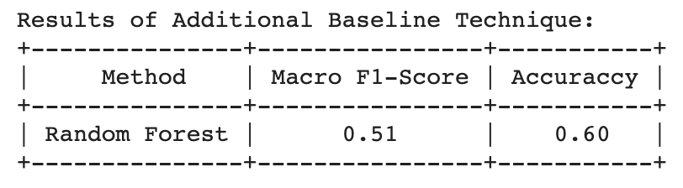

[Figure 1.31: Macro F1-Score Achieved on Implementing Random Forest Classifier](https://colab.research.google.com/drive/1eMmc-bLMbEa2E7iGwnxcUhBsCBYH4V56#scrollTo=7lcAgDloJZ6l)

On implementing the **Random Forest Classifier**technique on our **OLID 2019 Dataset,**we achieved a **Macro F1-Score**of **0.51**. When implementing our baseline methodologies, various parameters can be experimented with or changed. In the following sections, we would be explaining the reasoning behind our implementation of different parameters.

3.7 Parameters Employed on Recommended Approaches

For any sound **ML**model or algorithm, it is vital to manipulate the different parameters and features at our disposal. The sole purpose behind this manipulation is to ensure we achieve optimal results and do not exercise redundant methods in the future. The principal parameters employed in our exploratory venture is:

Implementation of Glove Vectors:

The tweets from the **OLID 2019 Dataset**have been encoded using **Word Embeddings.**Although there are **five**different **Glove Vector Embeddings**available, we use the **100 dimensional**and**200-dimensional Word Embeddings.**The reason behind our fixed **Glove Vector**parameter is that **Twitter**allows a maximum of **140**words that a user can write. Since a **100-dimensional Word Embedding**cannot capture the entire context of the tweet, we strengthen our execution with the addition of a **200-dimensional Word Embedding.**

Execution of One-Hot Encoding:

The **OLID 2019 Dataset**has a considerable amount of **Categorical**or **Nominal Data**present within the three different subtasks. Each **Categorical Data**has one of the following labels: **NOT, OFF, TIN, UNT, OTH, GRP**and **IND.**Since most **ML**algorithms cannot work directly with such **Nominal Values**, it is essential to convert these labels to numerical values. Implementing **One-Hot Encoding**as a **Fixed Parameter**improves the ML model's learning rate and aids in the efficiency of executing it.

Training Data Accepted :

For our exploratory venture, we have adopted the **OLID 2019 Dataset**from **SemEval Competition.**

However, on further examination of the dataset, it was determined that there are similar **Training Datasets**available on **Online Machine Learning**platforms like **Kaggle**and **Dataquest.**

We did try adopting the **Hate Speech Dataset**from the **Toxic Identification Challenge**at **Kaggle**, but the dataset didn't improve our **Accuracy**or **Macro F1-Score.**However, it is recommended for further study to utilise one particular dataset and train the model on it before exposing it to unknown features and characteristics. The reason being that any **ML**model is similar to a new-born baby. Asking the baby to drive a run a marathon will only dampen its learning rate and growth even before it has taken a step.

Maximum Number of Epochs for Model Training:

After a thorough critique of the previous approaches, it has been observed that the maximum number of epochs used for any training model has been **20 epochs.**We have decided to **Vary**the **Learning Rate Parameter**to understand better how our model behaves for our project. Having a limit on**epochs**is to notice if there is a decrease in error with every iteration. Past projects and researchers have varied and manipulated the number of epochs they would want to train the **ML**model. The constant variation in epochs is to keep the **Validation Error**in check and **Prevent Overfitting.**

* 1. Supplementary Evaluation Conducted

The primary goal of our project is to predict which **Category**or **Instance**of our **Sub-Tasks**does tweets from the **OLID 2019 Dataset** belong to. To measure the model that best predicts which category a tweet belongs in, we use various evaluation metrics. The primary evaluation metric remains the **Macro F1-Score,**but further analysis led us to compare the **Accuracy** obtained between the models implemented.

It is, however, essential to recognise the prioritisation of the **Evaluation Metrics.**We would be prioritising our models for our exploratory venture according to the **Macro F1-Score**followed by their **Accuracy.** A higher weightage is given to **Macro F1-Score**because it provides us with a holistic view by averaging **Precision**and **Recall.**We place **Accuracy**as our second evaluation metric because our goal has been to deliver consistent results irrespective of the dataset our model gets exposed to. On the contrary, **Precision and Recall** would play an essential role in repeating the same algorithm multiple times on a set dataset and observing how close the valid labels are correctly identified.

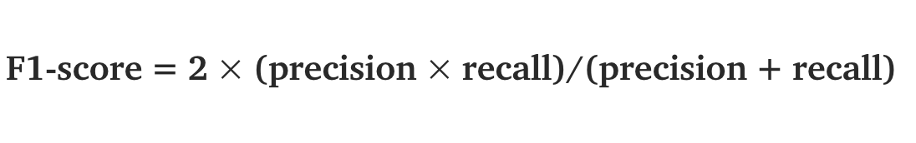

[Figure 1.32: Formula of F1-Score](https://towardsdatascience.com/multi-class-metrics-made-simple-part-ii-the-f1-score-ebe8b2c2ca1)

Since the **Macro F1-Scores**obtained from our **ML**and **DL**models do not differ significantly, we do not employ **Statistical Tests to compare our models.** In the event of further research and future work in our project, it is recommended to deploy the **Stuart Maxwell Test**to verify the **Statistical Significance**of our **Macro F1-Score. This is because the Stuart Maxwell Test is extremely useful in classification models dealing with multi-labelled data present in the OLID 2019 Dataset.**

4. Software Design & Testing

In our fourth chapter, we build upon the narrative of our notable **ML** models implemented. Here, we provide a detailed account of the **Software Methodology** performed, **Key Package** and **Components** utilised, and an extensive report of how **Testing** was carried out on our **ML** model.

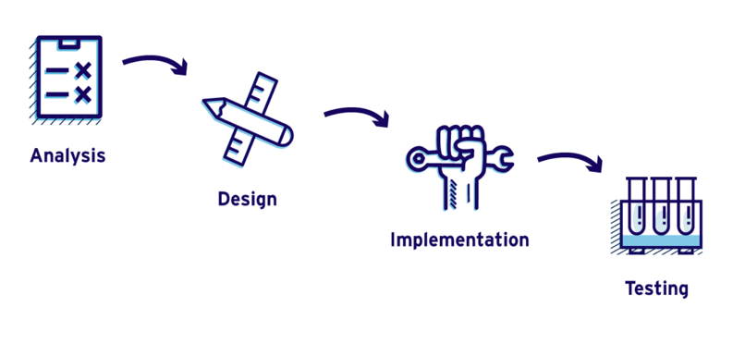

[Figure 1.33: Example of a Software Development Model](https://learn.marsdd.com/article/product-development-the-waterfall-methodology-model-in-software-development/)

## 4.1 Software Methodology Performed

To successfully implement our **Machine Learning**model, we need to have a robust and supportive **Software Development Methodology.**While there are many methods available for **Software Development,**we would be performing the **Agile Development Framework.**

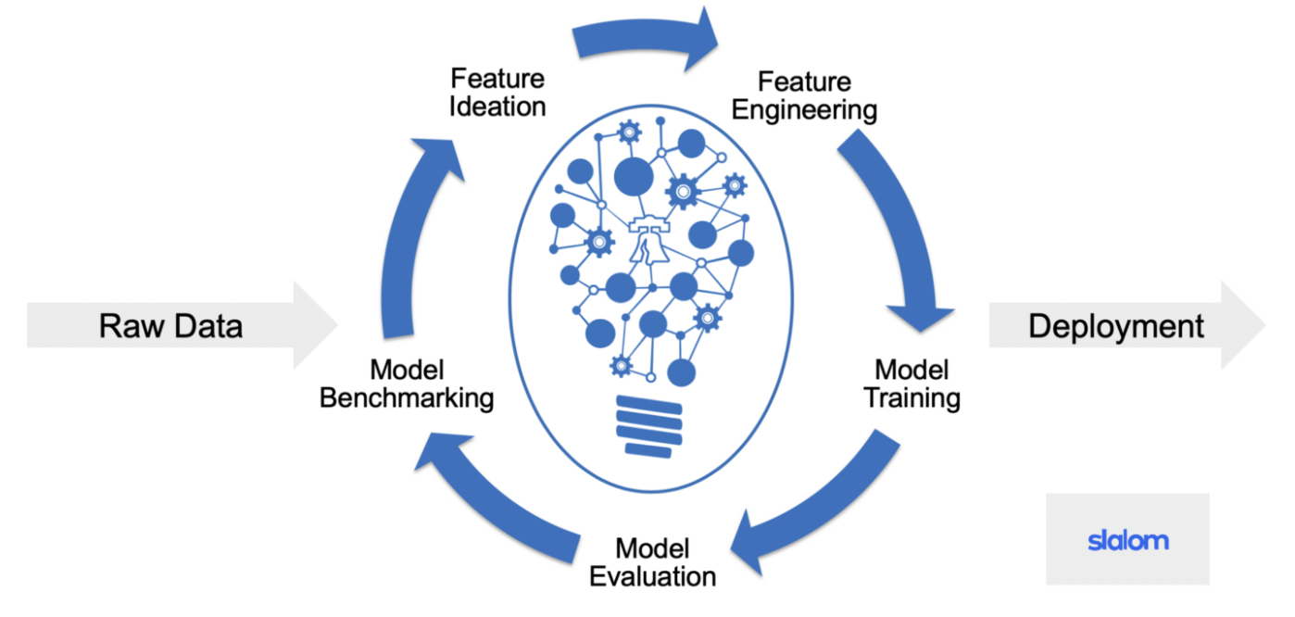

[Figure 1.34: Structure of Agile Framework in Machine Learning](https://medium.com/qash/how-and-why-to-use-agile-for-machine-learning-384b030e67b6)

The **Agile Development Framework**encompasses the idea of iterative development, where the solutions evolve as we progress from one stage to another. This evolving of solutions is a valuable trait present in the **Agile Methodology**, essentially because it keeps us focussed on obtaining accurate and optimal results. Additionally, after each sprint, we evaluate how well the **ML**model performs by comparing the results. This iterative evaluation helps us determine when to stop the model development and move on to the next stage. An example of our improved accuracy obtained in three sprints is provided below.

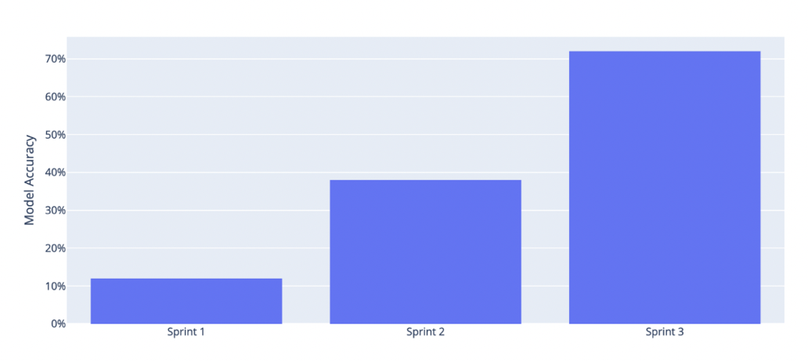

[Figure 1.35: Increased Model Accuracy after Each Sprint](https://medium.com/qash/how-and-why-to-use-agile-for-machine-learning-384b030e67b6)

## 4.2 Key Libraries & Features Implemented

Technology has developed at such a rapid pace that functionalities and implementations that weren't imaginable earlier are processed in microseconds today. [(Python Machine Learning)](https://www.activestate.com/blog/top-10-python-machine-learning-packages/) There were a critical number of components integral to our **ML** model's successful performance for our exploratory venture. These are as follows:

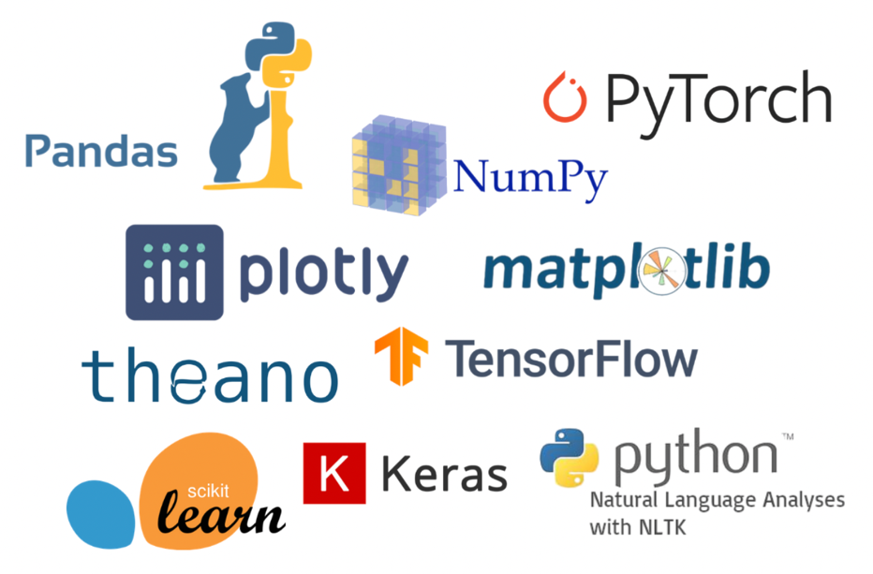

[Figure 1.36: Major Libraries used for Natural Language Processing](https://www.fireblazeaischool.in/blogs/python-libraries-for-machine-learning/)

**Keras**

It is one of the most widespread libraries in python that provides a high-level neural network **API.**The significant benefits of implementing **Keras**are the excellent use of experimentation and the secure creation of Neural Networks. It is a powerful and easy-to-use open-source **Python**library for both developing and evaluating **ML**and **DL**models.

**NumPy**

Another essential library in Python is **NumPy.**It allows multi-dimensional array and matric processing along with an extensive collection of high-level mathematical functions. Therefore, the NumPy library is beneficial, given that we have such a large corpus of text from our **OLID 2019 Dataset.**Additionally, other libraries that we have employed, like **Scikit-Learn,**utilise **NumPy**arrays as input.

**TensorFlow**

Another vital open-source **Python**library developed by Google is instrumental for the high performance of numerical computations. It's fundamentally a framework for creating and running calculations involving tensors. One of its most prominent benefits is the different **ML**algorithms it supports. This is extremely helpful, given that it provides us with an opportunity to experiment with varying baseline techniques for our **OLID 2019 Dataset.**

**Scikit-Learn**

Another notable library available in **Python**is **Scikit-Learn.**It is built upon the **Matplotlib** and **NumPy** libraries. It is beneficial for **Natural Language Processing**because of the wide range of algorithms and analysing tools available. Since our **OLID 2019 Dataset**consists of a large corpus of text, **Scikit-Learn**is remarkably effective in performing **Natural Language Processing**and extracting data from text.

**Pandas**

Another **Python**library we have implemented is **Pandas.**Essentially for its high performance and easy to use data structures and analysis tools. Moreover, it is swift and is widely flexible to use in conjunction with other **Python**libraries used for **Machine Learning**and **Natural Language Processing.**Additionally, a **Pandas** data frame can be easily created from existing datasets storage in SQL Databases, CSV files, Excel files, or Online Forums and Competitions. An example is showcased below:

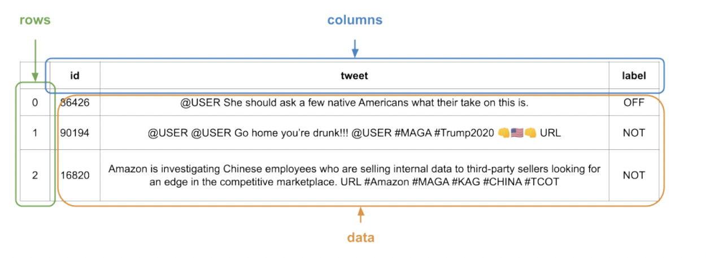

[Figure 1.37: A Pandas Data Frame Example](https://www.activestate.com/blog/top-10-python-machine-learning-packages/)

Maximum Number of Feature Variables:

For our exploratory venture, the maximum number of words we would recognise as features will be **10,000.**The reason behind this is the rigorous pre-processing that the **OLID 2019 Dataset**has gone through. Having excluded redundant features like **URL's, @Mentions, Special Characters, Multi Spacing,**and **Emojis,**the pre-processed tweet's average length reduces considerably. Further, exploratory analysis of the pre-processed tweets showcases that the median size of our cleaned tweet is a maximum of **1 Word**or **Less**without being repeated. Given that we have **13,240**rows, we have decided to approach a whole number of **10,000**words as features. We can always **Vary**our **Feature Parameters**to understand how the model behaves when we change the maximum number of words for further analysis or research.

## 4.3 System Testing Conducted

For the robust performance of an **ML**model, it is crucial to conduct systematic testing of our **Data Pipeline.**The process of asserting that the processed data in our pipelines is the one we want to implement is defined as **Data Pipeline Testing.**For our testing to be carried efficiently, we would be executing **Regression Testing**. The purpose behind using testingis to ensure that the functionalities of our source code work correctly, even if there are modifications towards the later stages of our project.

To carry out our testing, we proceeded with debugging our source code. Once the bugs were identified, measures to fix and correct them was carried out. For effective **Regression Testing**to be carried out, prioritisation of test cases is required. The testing was carried out in functionalities most visible to the user, followed by constant comparison of our evaluation metrics and continuous **Model Tuning by changing parameters.**

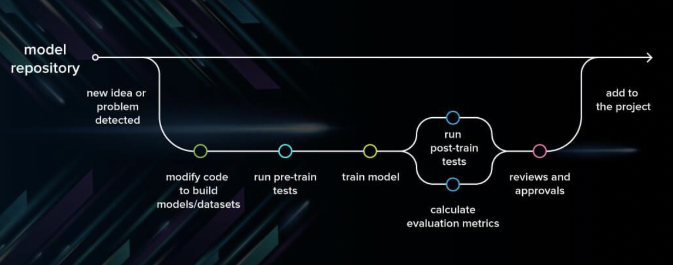

[Figure 1.38: A High-Level Overview of Machine Learning Model Testing](https://serokell.io/blog/machine-learning-testing)

Furthermore, precise and rigorous **Unit Testing**was carried out on our **Data Pipeline.**The tests conducted were:

**Missing Values Test:**

We need to ensure that the **Dataset**we **Train**and **Test**our model on is free of missing values **(NA's)**

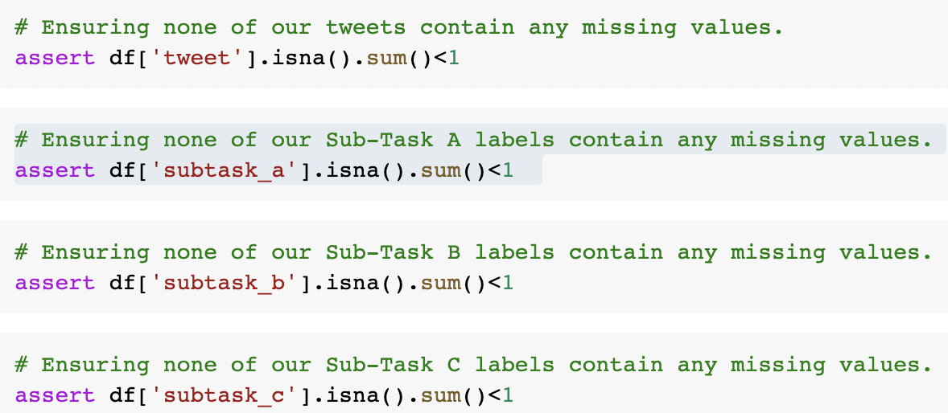

[Figure 1.39: Source Code for Missing Values Test](https://colab.research.google.com/drive/18BtVVTZdPQTDITtUQQZPM-IQUiB_P3_a#scrollTo=I0PtFhiEWSRY)

**Duplicate Values Test:**

We need to ensure that the **Dataset**we **Train**and **Test**our model does not contain repetitive tweets since it would hinder the efficiency of our model.

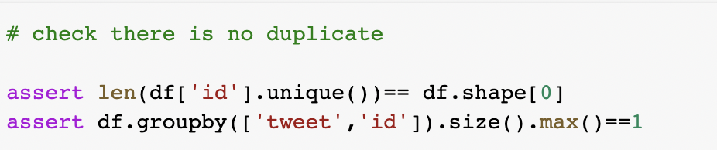

[Figure 1.40: Source Code for Duplicate Values Test](https://colab.research.google.com/drive/18BtVVTZdPQTDITtUQQZPM-IQUiB_P3_a#scrollTo=SUUIhmDcWNG4)

**Shape Values Test:**

We need to ensure that the **Dataset**we **Train**and **Test**our model contains tweets and labels associated with each id number.



[Figure 1.41: Source Code for Shape Values Test](https://colab.research.google.com/drive/18BtVVTZdPQTDITtUQQZPM-IQUiB_P3_a#scrollTo=SUUIhmDcWNG4)

**Data Pre-processing Test:**

One of the most integral parts of our testing methodology is to ensure that the data we want our model to **Train** and **Test** on is the one we have cleaned and pre-processed. To provide our pre-processing steps are carried out successfully, we run the below testing.

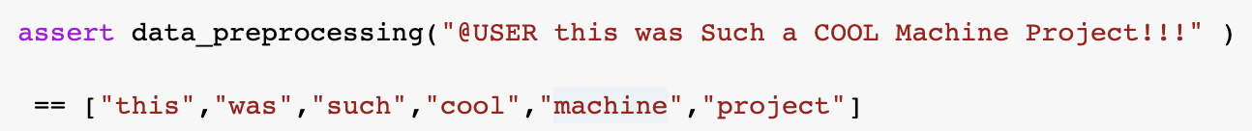

[Figure 1.42: Source Code for Data Pre-processing Test](https://colab.research.google.com/drive/18BtVVTZdPQTDITtUQQZPM-IQUiB_P3_a#scrollTo=lpYK4Dg3d9kt)

5. Results & Outcomes

The fifth chapter of our thesis presents the results obtained from our **ML Models**, a comparison of the outcomes obtained with that of previous approaches, specifically from teams who participated in the **SemEval - Task 6 Competition**and an understanding of the sensitivity of our models with varying parameters.

After extensive experimentation with various models and baseline techniques, we can infer the results obtained in **Identifying and Categorising Offensive Language in Social Media.**

[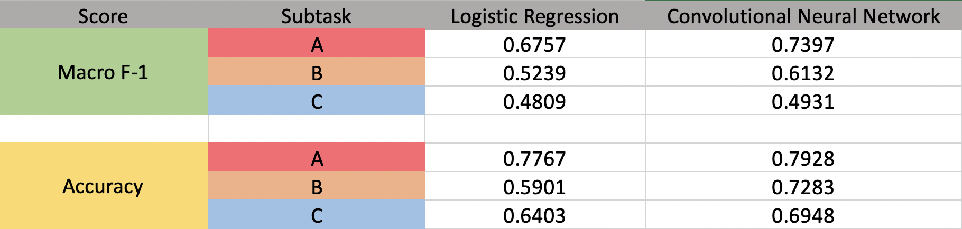](https://github.com/YagyanshB/SemEval-Task6-CS408)

[Figure 1.43: Results of our Baseline Techniques across different Subtasks](https://github.com/YagyanshB/SemEval-Task6-CS408)

The above table presents the results for our two classification techniques implemented. From the results, we can clearly distinguish that the architecture that performs best on the **Macro F1-Score**is the **Convolutional Neural Network**model.

5.1 Convolutional Neural Network Model Results

The **CNN**model for **Subtask-A**and **Subtask-B** obtained a **60%+ Macro F1-Score.**The averaged **Macro F1-Score**across all three tasks for our **CNN**model is **0.6153.**Our **CNN**architecture generated a **73.8% Accuracy**on our **OLID 2019 Dataset.**It implies that our model correctly identified **True Positives**and **True Negatives 73**times out of every **100**iterations.

5.2 Logistic Regression Model Results

The **Logistic Regression**model obtained the highest **Macro F1-Score**in  **Subtask-A**primarily because of the binary label splitting of categorising the tweets into **Offensive (OFF)**or **Not Offensive (NOT).**The averaged **Macro F1-Score**across all three tasks for our **Logistic Regression**model is **0.5601.**Our **Logistic Regression**study generated a **77% Accuracy**in **Subtask-A**compared to an **Averaged Accuracy**of **66%**across all the **Subtasks**in the **OLID 2019 Dataset.**

5.3 Comparison of Results with OffensEval 2019

Various teams across the globe have tried solving the **Hate Speech**problem set in the **SemEval 2019 Competition.**Since the competition specifically evaluated models with the **Macro F1-Score**metric, we would be doing so too.

**Worldwide Results of the Competition:**

**Sub-Task A – Rank – 1st – F1 Score: 0.938750029**

**Sub-Task B – Rank – 1st – F1 Score: 0.715679443**

**Sub-Task C – Rank – 1st – F1 Score: 0.580794253**

**Students from Imperial College London bagged the first position in the Sub-Tasks B and C.**

**KALY***(Kieren Amal Leif Yagyansh)* **Model Results of the Competition:**

**Sub-Task A – F1 Score: 0.739785426**

**Sub-Task B – F1 Score: 0.513244957**

**Sub-Task C – F1 Score: 0.694892562**

While the results obtained from our **ML**and **DL**model is not in the higher end of the spectrum, it is worth noting that we successfully achieved a better **Macro F1-Score**and **Accuracy**than **60%**of the teams that participated in the **SemEval 2019 Competition. However,** the aim for this project had never been to outflank the previous participants but to strive for a **100% Accuracy**and perfect **Macro F1-Score.**

6. Conclusion & Future Development

Technology today can provide us with the weather forecast, extract information, or even aid in navigation. However, it cannot tell us how we feel. Tomorrow, if we prompt our iPhone with, "Hey Siri! How do I feel"; the response would not be one we would be expecting. Instead, the machine would reply with either "Interesting Question" or "Good to know". These questions do seem unconventional to ask, but rapid advancements in sentiment analysis and machine learning are strengthening them to answer such questions.

Our exploratory venture has only given us limited knowledge about the potential **Machine Learning**techniques and models have. Whilst **Logistic Regression**and **CNN**have represented substantial outcomes with the **OLID 2019 Dataset,**there is still significant room for improvement. The development of **ML**models could come from blending different **Deep Learning**models to better in the classificational tasks of **SemEval Competition.**Moreover, ML models face one of the most considerable constraints, determining the best performing parameters to optimise the training process. To implement the most suitable parameters would require a large amount of **Computational Power**and **Permutations**of different parameters together. Additionally, for our future work we would like to implement the unification of the **BERT (**State-of-the-art**)** model with our baseline models.

The research conducted through the course of my project is just the tip of the iceberg. The domain of **Machine Learning**and **Sentimental Analysis**is yet to be harnessed to its full potential. This advancement in **ML**is imperative for the widespread benefits it can provide. Currently, Sentiment Analysis's applications are purely commercial, with movie producers using it to evaluate audience feedback and corporations using it to assess consumers' reactions towards products. However, if the rate of progress in **Sentiment Analysis**and **ML**remains the same, it could solve a myriad of problems.

The **COVID-19 Pandemic**has highlighted how depression, anxiety and mental health are significant issues faced by people worldwide. These people use the Internet as a refuge to seek comfort. With **Sentiment Analysis**in play, we could help improve the lives of people facing such challenges by providing help and support. Moreover, we could implement it to gauge radicalism, sexism and racism on the Internet. In conclusion, the sole purpose of this project has been to make the Internet a safe place for us. That time is not far when our phones become our therapist.

"Hey, Siri! How are we today?"

References

[1] Athey-Susan, Mobius-Markus, Pal-Jeno, 2014, ‘Social Media and News Consumption’, Stanford University

[2] Netflix, 2020, ‘The Social Dilemma’, [www.netflix.com/thesocialdilemma](http://www.netflix.com/thesocialdilemma)

[3] Nikki, 2020, ‘How I took Control of my Social Media’, Young Minds UK  
[4] Segal-Jeanne, Robinson-Lawrence, 2020, ‘Bullying and Cyberbullying’, Help Guide UK

[5] McCarty-Niall, 2020, ‘Facebook Removes Record Number of Hate Speech Posts’, Forbes

[6] Allan-Richard, 2017, ‘Hard Questions : Who Should Decide What is Hate Speech’, Facebook

[7] Haynes-Trevor, 2018, ‘Dopamine, Smartphones & You: A Battle for your time’, Harvard University

[8] Yoon-Kim, 2014, ‘Convolutional Neural Networks for Sentence Classification’, New York University

[9] Prince, 2019, ‘A Gentle Introduction to Machine Learning’, Towards Data Science

[10] Priakanth-Gopikrishnan, 2021, ‘Machine Learning Techniques for Internet of Things’, Kongu College

[11] Zenaty-Zeyad Al, 2019, ‘That’s Offensive: An All-Out Search for an Ensemble to Identify and Categorize Offense in Tweets’, Alexandria University

[12] Salminen, Sengün, Corporan, Jung, Jansen, 2020, ‘Exploring Relationship between Online Toxicity and News Topics’

[13] Park, Fung, 2017, ‘One Step and Two Step Classification for Abusive Language Detection on Twitter’, Hong Kong University of Science & Technology

[14] De Souza-Gabriel, 2020, ‘Automatic Offense Language Detection from Twitter Data using Machine Learning and Feature Selection of Metadata’, Sheffield Hallam University

[15] Gandhi-Rohith, 2018, ‘Naïve Bayes Classifier’, Towards Data Science

[16] Bhandary-Unnathi, 2019, ‘Detection of Hate Speech in Videos using Machine Learning’, San Jose State University

[17] Patra, Das, Bandyopadhyay, 2016, ‘Detecting Stance in Tweets using Support Vector Machines’, Jadavpur University

[18] Zhu, Tian, Kübler, 2019, ‘Identify Offensive Tweets Using BERT and SVM’s’, Indiana University

[19] Zampieri, Malmasi, Nakov, Rosenthal, Farra, Kumar, 2019, ‘Identifying and Categorising Offensive Language in Social Media’, University of Wolverhampton

[20] Zampieri, Malmasi, Nakov, Rosenthal, Farra, Kumar, 2019, ‘Predicting the Type and Target of Offensive Posts in Social Media’, University of Wolverhampton

[21] Puiu, Brabete, 2019, ‘ Convolutional Neural Networks and Random Neural Networks for Offensive Language Detection in Social Media’, Imperial College London

[22] Tawalbeh, Hammad, Smadi, 2020, ‘Identifying Multilingual Offensive Tweets using Weighted Ensemble and Fine-Tuned BERT’, Jordan University of Science and Technology

[23] Aggarwal, Horsmann, Wojatski, Zesch, 2019, ‘BERT and Two Vote Classification for Categorizing Offenses’, University of Duisburg-Essen

[24] Mitrović, Birkeneder, Granitzer, 2019, ‘A Deep Learning Model for Offensive Language Detection’, University of Passau

[25] Pennington, Socher, Manning, ‘Global Vectors for Word Representations’, Stanford University

Appendix

Here we provide a simple explanation and guide for implementing our classification techniques. A total of **4 Baseline Techniques** been implemented. These are present within the below files:

1. Additional_Baseline_SVM.ipynb (Corresponding to Support Vector Machine method)
2. Random_Forest_Additional_Baseline.ipynb (Corresponding to Random Forest method)
3. Logistic_Regression _Baseline_1.ipynb (Corresponding to Logistic Regression method)
4. Convolutional_Neural_Netwok_Baseline_1.ipynb (Corresponding to CNN method)

We have used **Google Collab** for the entire software development and implementation of our source code and project. The reason being its user-friendly interface and accessible **GPU** it provides. In order to perform the implementation of our **ML** and **DL** models, the steps below need to be followed:

1. Download the **OLID_2019 Dataset**
2. Set the **File Paths** in **Google Collab** as shown in our **Source Code** based on your google drive or local computer directory
3. Install the **Glove Vector Embeddings** onto the local developing environment
4. Run the **Data_Splitting_And_Exploratory_Analysis.ipynb** file to visualise and view the **Dataset** at our disposal
5. Run the **Pre_Processing_Data.ipynb** to cleanse and pre-process the **OLID 2019 Dataset** provided
6. Implement the **Additional Baseline Techniques** using either **Additional_Baseline_SVM.ipynb** or **Random_Forest_Additional_Baseline.ipynb** file
7. Implement the **Logistic Regression Baseline Technique** using the **Logistic_Regression _Baseline_1.ipynb** file
8. Implement the **Convolutional Neural Network Baseline Technique** using the **Convolutional_Neural_Netwok_Baseline_1.ipynb** file
9. Perform **Unit Testing** on our **OLID 2019 Dataset** using the **Unit_Testing_Data_Pipeline.ipynb** file to check if the data we want to feed our model is the same as we expected it to be